Characterization and Modeling of Biomimetic Untethered Robots Swimming in Viscous Fluids Inside Circular Channels
Fatma Zeynep Temel, Aydek Gokce Erman, and Serhat Yesilyurt, Senior Member, IEEE
Abstract—Miniaturized robots with bio-inspired propulsion mechanisms, such as rotating helical flagella, are promising tools for minimally invasive surgery, diagnosis, targeted therapy, drug delivery and removing material from human body. Understanding the swimming behavior of swimmers inside fluid-filled channels is essential for design and control of miniaturized robots inside arteries and conduits of living organisms. In this work, we present scaled-up experiments and modeling of untethered robots with rotating helical tails placed inside tubes filled with viscous fluids to mimic swimming of miniaturized robots in aqueous solutions. A capsule that contains the battery and a small dc motor is used for the body of the robots. Helical tails with different wavelengths and wave amplitudes are used in experiments to compare swimming speeds and body rotation rates of robots in a cylindrical channel with the diameter of 36 mm. Three-dimensional governing partial differential equations of the fluid flow, Stokes equations, are solved with computational fluid dynamics (CFD) to predict velocities of robots, which are compared with experiments for validation, and to analyze effects of helical radius, pitch and the radial position of the robot on its swimming speed, forces acting on the robot and efficiency.

Index Terms—computational fluid dynamics (CFD), in-channel swimming, low Reynolds number swimming, swimming micro-robots

INTRODUCTION
Miniaturized swimming robots have great potential to revolutionize modern medicine; risks of many life-threatening operations and procedures can be reduced significantly. For instance, potent drugs can be delivered to target organs, tissues and cells; arterial build-up can be removed to enhance blood flow in vital organs; diagnostic information can be collected and delivered from directly within organs and tissues, etc. A comprehensive survey of development of micro robots and their potential impact in medicine is provided by Nelson et al. [1].
Propulsion mechanisms of macro scale objects in fluids are inadequate in micro scales where Reynolds number is smaller than 1 and viscous forces dominate. Purcell’s scallop theorem demonstrates that a standard propeller is useless for propulsion in micro scales [2]. However, microscopic organisms such as bacteria and spermatozoa can move up to speeds around tens of body lengths per second [3, 4, 5] with propulsion generated by their flagellar structures, which are either rotating helices or flexible filaments that undergo undulatory motion. Natural micro organisms with helical tails, such Escherichia coli (cell body is approximately 1×2µm with flagella in 20 nm in diameter and about 8 µm in length) exhibit run-and-tumble behavior that resembles to random walk of a brownian particle [5]: they swim in nearly linear trajectories (run) interrupted by erratic rotation of the cell in place (tumble) caused by reversing the direction of the rotation of the flagella.
Some microorganisms such as Escherichia coli and Vibrio alginolyticus use their helical flagella for propulsion in aqueous solutions; a typical organism uses a molecular motor inside the body to generate the torque required to rotate the flagellum. Micro-scale control strategies for flagellated bacteria are demonstrated chemically [6] and magnetically [7]. Martel [8] presents a detailed review and list of demonstrations of magnetotactic bacteria as controllable micro and nano robots inside micro vessels and capillaries as small as 5 µm inside the body [7].
In-channel experiments and modeling studies are necessary to understand the motion and optimization of micro robots inside capillaries and blood vessels. A number of studies in literature report experiments with E.coli in channels and capillaries [9, 10, 11, 12, 13]. These results are significant in showing hydrodynamic effects play an important role in swimming of bacteria in channels, and flagellar actuation mechanism is very effective even in narrow channels compared to the size of the organism. Molecular interaction forces between the swimmers and the channel walls lead to adhesion when the distances are very close. Authors report that motility is higher in the 10-µm capillary than the 50-µm one [9], and bacteria swim unidirectionally in the 6-µm capillary, while the cell speed and run time remain almost the same as the ones measured in the bulk [10]. Biondi et al. [11] measured that average cell speeds are the same for channels with 10 µm depths or more, but 10% higher in 3-µm channels and 25% smaller in 2-µm channels than the ones measured in the bulk. Authors state that drag effects are only important for E.coli swimming inside channels having a height of 2 µm or smaller, where the channel size is very close to the size of the head. DiLuzio et al. [12] performed experiments on smooth-swimming E. coli cells, which do not tumble, in rectangular channels having widths (1.3 - 1.5 µm) slightly larger than the diameter of the body of the organism and showed that some types of surfaces are preferred by bacteria than others and wobbling or rotational brownian motion eventually caused cells to separate from the wall. Authors report that rotational brownian motion is suppressed more and cells swim faster when cells swim near the porous agar surface than when cells swim near the smooth PDMS surface, and propose that the hydrodynamics is responsible for this behavior. The lower limit for the channel width that E.coli and B.subtilus can continue swimming is discussed by Maennik et al. [13]. Authors concluded that E. coli can swim in a very close proximity (~40 nm) to a planar surface and adhesive and friction forces exceed the force provided by flagellar motors or bacteria once the diameter of bacterium becomes comparable to the width of the channel [13]. In the same study, authors presented that E.coli and B.subtilus are still motile in channels having a width approximately 30% larger than bacteria diameters [13].
Near solid boundaries bacteria were observed to follow circular trajectories that are influenced by hydrodynamic effects [14, 15] and altered by brownian forces that change the distance of the organism from the wall [16, 17]. Vigeant et al. [14] studied the attraction between the swimming organisms and a solid surface and proposed that the force holding swimmers near the surface is the result of a hydrodynamic effect when the cells are within about 20 nm to 10 µm of the surface, and electrostatic influences are important when the cells are closer than 20 nm from the surface and lead to the adhesion of the cell. Authors report that stable swimming near the surface for periods well over one minute are observed, ultimately leading cells to move away from the wall by brownian motion. Lauga et al. [15] developed a hydrodynamic model and compared with experiments using E. coli bacteria near surfaces and observed that bacteria follow a circular trajectory near a solid boundary as a result of force-free and torque-free swimming and hydrodynamic interactions with the boundary. Authors use the hydrodynamic model to show that the speed and the radius of the circular trajectory of the swimmer depends strongly on the distance to the wall. Li et al. [16] report experiments and simulation results for swimming trajectories of singly flagellated bacterium C. crescentus near a glass surface. Authors observed that brownian motion is coupled with hydrodynamic interaction between the bacterium and the surface, influences the swimming of the organism by randomizing the displacement and direction, and leads to the variation of the swimming speed and the trajectory [16]. Experiments performed using S. marcescens attached to the 5 µm diameter polystyrene beads showed that beads have helical trajectories away from the wall, however show stochastic behavior near the wall [17].
Hydrodynamic models of low Reynolds number swimming are based on asymptotic solutions of Stokes equations and no-slip boundary conditions, such as presented by Lighthill [18], and resistive force coefficients, that are based on the drag anisotropy on slender rods, e.g. in [19], where present an excellent overview of hydrodynamic models of swimming. The motion of E. coli near a planar surface is modeled using resistive force coefficients and confirmed the resultant circular trajectory with experiments by Lauga et al. [15]. Recently, in-channel swimming of infinite helices and filaments that undergo undulatory motion is studied by Felderhof [20] with an asymptotic expansion, which is valid for small amplitudes; results show that the speed of an infinitely long helix placed inside a fluid-filled channel is always larger than the free swimmer and depends on the tail parameters such as the wavelength, amplitude and the radius of the tail.
Analytical models that describe the equation of motion for artificial structures swimming in blood vessels are reported in recent years. Arcese et al. [21] developed an analytical model that includes contact forces, weight, van der Waals and Coulomb interactions with the vessel walls and hydrodynamic drag forces on a spherical micro robot in non-Newtonian fluids to address the control of magnetically guided therapeutic micro robots in the cardiovascular system.
In addition to analytical models, there are numerous examples of numerical solutions of Stokes equations for micro swimmers in unbounded media and near planar walls with no-slip boundary conditions; representative ones are the following. Motion of Vibrio alginolyticus was modeled numerically by Goto et al. [22] with the boundary element method (BEM); authors showed that model results agree well with observations on the strains of the organism that exhibit geometric variations. Ramia et al. used a numerical model based on BEM and calculated that the micro swimmer's velocity increases by only %10 when swimming near a planar wall, despite the increase in drag coefficients [23].
No-slip boundary conditions are commonly adopted for modeling micro organisms swimming in unbounded media and near planar walls, e.g. [15, 18, 19, 22, 23, 24, 25, 26]. For example, Shum et al. used a boundary element method (BEM) to study entrapment of bacteria near solid surfaces, and used no-slip boundary conditions to study swimming of a micron-sized micro organism as near as 35 nm to a planar surface [24]. However, from a general perspective no-slip boundary conditions are questionable especially in sub-micron scales [27, 28, 29, 30]. In addition to molecular forces, wetting and shear rate, slip length in solid-fluid interfaces depends on surface roughness, nano bubbles, contamination and viscous heating [31, 32, 33]. Although in some studies it is reported that slip exists both on hydrophilic and hydrophobic surfaces and the degree of slip differs according to the wetting of the surface [33], with improvements on the contact angle measurement techniques, boundary conditions on the hydrophilic surfaces are adopted as no-slip by several authors [30, 31, 34, 35]; non zero slip length is observed in the presence of nano bubbles and at very high shear rates [27, 31]. Blood vessels and other conduits in the human body are covered with hydrophilic surface tissue, which is the endothelium and used to render polymers hydrophilic [36, 37]. In addition, most of the bacteria show hydrophilic surface properties [38, 39]. Therefore, no-slip boundary conditions are assumed for swimming of bacteria in modeling studies, e.g. [18, 19, 15, 22, 23, 24, 25, 26], and adopted here as well.
Another question is about the Newtonian fluids used in experiments and modeling studies. The red blood cells, which present in the blood, cause it to behave like a non-Newtonian fluid [40]. The blood plasma, on the other hand, is a Newtonian fluid and more than 50% of it is water. A micro swimmer would experience the same effects with particles (cells) in the blood, therefore, at the micro and nano scales, blood can be considered as Newtonian fluid for modeling studies [40]. In addition, the experimental results of Liu et al. [41], who studied visco-elastic effect of the non-Newtonian fluid using Boger fluid in their scaled-up setup, which is used to measure the force-free swimming speed of a rotating rigid helix, show that the difference in the forward velocities of rotating helices in viscous and visco-elastic fluids is not crucial.
Inspired by microorganisms with helical flagella, swimming of one-link helical magnetic micro structures is demonstrated using external rotating magnetic fields, since artificial reproduction of the mechanism used by natural micro swimmers is very difficult in nano and micro scales [42, 43, 44]. However, technological challenge may not be too prohibitive in mm-scale, which is still in the low Reynolds number regime. Moreover, swimming of natural micro organisms and magnetically controlled bio-carriers [7] in channels differ than the swimming of one-link artificial swimmers. Thus, experiments with scaled-up robots swimming in viscous fluids have been used to demonstrate the efficacy of the actuation mechanism as well as validate hydrodynamic models, since low Reynolds number flows are governed by Stokes equations regardless of the length scale.
The Reynolds number, which characterizes the relative strength of inertial forces with respect to viscous ones, is given by:
where ρ and µ are density and the viscosity of the fluid, and U and ℓ are the velocity and length scales of the flow. According to Purcell [2], a man would experience the same forces and effects as a bacterium if he tries to swim in a pool that is full of molasses; since both situations would have the same low Reynolds number and same physical conditions. For example, the Reynolds number for the swimming of a generic bacterium with a length scale of 1 µm at the speed of 10 µm/s in water is about, Re = ρUℓ/µ = 1000×10⁻⁵×10⁻⁶/10⁻³ = 10⁻⁵. Similarly, for a cm-scale robot swimming with the speed of 1 cm/s in viscous oil with the viscosity 10000 times the viscosity of water and about the same density as water, the Reynolds number is, Re = ρUℓ/µ = 1000×10⁻²×10⁻²/ 10⁴ = 10⁻⁵. Therefore, the hydrodynamic properties of the swimming of bacteria in water and the robot in oil are dynamically similar. The test data obtained for the cm-scale model can be applied to µm-scale one; dynamical similarity is commonly practiced in the design of large scale objects such as aircrafts and submarines as well [45].
There are a number of works reported in literature that takes advantage of the hydrodynamic similarity of low Reynolds numbers and uses experiments in viscous fluids at cm-scales to study the swimming of bacteria in micro-scales. Behkam and Sitti [46] calculated the thrust force generated by a rotating helix using scaled-up characterization experiments; the deflection of a very thin (1.6 mm) cantilever beam due to the rotation of helical tail in silicon oil-filled tank is measured to calculate the thrust force. Another scaled-up model is presented by Honda et al. [47] where rotating magnetic field is used as external actuation to obtain propagation of a cm-long helical swimming robot in a silicon oil-filled cylindrical channel. The linear relationship between the swimming speed of the robot and the excitation frequency is observed by authors and results agreed well with the hydrodynamic model developed by Lighthill [18] based on the slender body theory for microorganisms. Kim et al. [48] analyzed digital video images of a macroscopic scale model that demonstrated the purely mechanical phenomenon of bacterial flagella bundling; the macroscopic scale model allows to determine the effects of parameters that are difficult to study in micro-scale such as the rate, effects of the helical radius and the pitch, which are hard to measure accurately, and the direction of motor rotation [48]. Another study conducted by Kim et al. [49] performed to measure the velocity field for rotating rigid and flexible helices, and study the flagellar bundling of E. coli or other bacteria, by building a scaled-up model, which ensures Reynolds number to be low, using macro-scale particle image velocimetry (PIV) system.
In our recent experiments, one-link micro robots were placed inside glycerol-filled glass channels of 1 mm inner-diameter and actuated by external rotating magnetic fields [50]. Results of the experiments indicate that a proportional relationship between the time-averaged velocity and the rotation frequency exists up to a step-out frequency, after which the robot's rotation is no longer synchronized with the magnetic field, similar to results observed in almost unbounded fluids in the literature [42, 43]. We also reported computational modeling of one-link swimmers with magnetic heads and helical tails swimming inside glycerol-filled glass channels [51]; the computational model predicted the speed of swimmers well and demonstrated that near wall swimming is faster than center swimming, which is faster than unbounded swimming. Furthermore, the model showed that the rotation of the helical tail produces a localized flow around the swimmer leading to forces and torques that alter the orientation of the swimmer in the channel [51].
Hydrodynamic effects need to be studied in order to improve understanding of the motion of micro robots inside vessels, arteries and similar conduits inside the body, as well as the motion of micro organisms inside channels and confinements. However, experiments with micro organisms and artificial micro structures pose many challenges such as controlling the geometry of the body and the tail which have a strong influence on the speed and efficiency. Therefore, experiments with cm-sized robots are advantageous since geometric parameters can be controlled and low Reynolds number conditions can be satisfied.
In this study, we describe a computational fluid dynamics (CFD) model, which is validated with experiments reported in our earlier work [52], to analyze the effects of the geometric parameters of the tail and the radial position of the robot on the speed and efficiency of the cm-size two-link robot swimming inside a circular channel filled with viscous silicone oil, which ensures low Reynolds number swimming conditions as adopted commonly in literature, e.g. [46, 47, 48, 49]. The CFD model is based on the solution of three-dimensional Stokes equations subject to no-slip boundary conditions on the body and the tail of the robot and on channel walls, as commonly used in similar studies for micro organisms swimming near solid walls, e.g. [15, 24, 26, 55] and validated by experimental results. Since, it is established by prior research in the literature that hydrodynamic effects are very important for the near wall swimming of natural organisms, e.g. [14, 15, 16, 17], we carried out a number of simulations with the CFD model to study the effects of tail design and the radial position on the swimming performance. Moreover, radial position of magnetic robots inside channels can be a control parameter as well [54] with the use of magnetic manipulation techniques that are demonstrated successfully in velocity and position control of magnetotactic bacteria [7] and artificial structures [53].

Methodology

Experiments
The two-link robot used in the experiments is untethered and consists of a body and a helical tail similarly to micro organisms. The body of the robot is made of a glass tube of outer diameter of 1.6 cm and thickness of 1mm and a plastic cover with outer diameter of 1.8 cm and length of 1 cm. Inside the glass tube, a power source, Li-polymer battery (3.7 V, 65 mAh) of dimensions 17.3×13.5×13.5 mm³; a brushless DC motor of diameter of 6 mm and length of 14 mm with 3V DC nominal voltage and 200 mA nominal current; and a small switch of dimensions 7×3×3 mm³ are held together with an adhesive putty that ensures rotational symmetry and neutral buoyancy of the body. Table 1 summarizes common dimensions of robots.
In order to study the effects of the helical pitch (wavelength) and radius (amplitude) of the helical tail on the swimming speed, 15 different helical tails are made of steel wire of diameter 1 mm. Tails are manufactured manually by wrapping the steel wire around rigid bars of desired diameter to obtain amplitudes, B, of 1, 2, 3 and 4 mm, which corresponds to a ratio between amplitudes and channel diameter, B/R_{ch}, 1/18 (0.056), 2/18 (0.112), 3/18 (0.167) and 4/18 (0.223). Then the coil is plastically deformed by extending it to desired wavelengths that correspond to 2, 3, 4 and 6 turns, N_{λ}, on the helical tail, which has a fixed length, 6 cm; the total length of the wire varies with the wavelength and amplitude. Only the tail with the largest amplitude, 4 mm, and the smallest number of turns, 2, was not manufactured with a satisfactory helical shape, thus experiments are not performed with that tail.
Fixed plastic couplings are used to secure each tail to the shaft of the dc-motor that protrudes from the capsule. The robot consisting of the capsule and the tail is placed inside an open-ended circular glass channel with the diameter of 3.6 cm and length of 30 cm inside an aquarium filled with silicone oil with a viscosity of 5.6 Pa-s (5000 times the viscosity of water) and a density of 1000 kg/m³ as shown in Fig. 1c. The body, which is used for all robots, is neutrally buoyant; however robots rest at the bottom of the horizontally placed channels due to the weight of the steel wire tail.
TABLE I: Common Dimensional Properties for Robots
Radius of the body, r_{b} | 0.8 cm
Total length of the body, L_{b} | 4 cm
Outer radius of the cap, r_{cap} | 0.9 cm
Length of the cap, L_{cap} | 1 cm
Apparent length of tails, L_{tail} | 6 cm
Length of couplings | 1 cm
Diameter of tail wire, 2r_{tail} | 1 mm
Length of the channel, L_{ch} | 30 cm
Diameter of the channel, 2R_{ch} | 3.6 cm
Maximum Reynolds number for the robots used in the experiments is calculated using diameter of the capsule body and maximum forward velocity reached by R10 in experiments as length and velocity scales as: Re = ρUℓ/µ = 1000×(1.01×10⁻³)×(16×10⁻³)/5.6 = 2.89×10⁻³, which is much less than unity confirming that the flow is well within the Stokes regime. As an example, a micro robot with the diameter of 32 µm and velocity of 100 µm/s traveling in water has the same Reynolds number as R10.
For each experiment, the battery that supplies power for the dc-motor is charged fully, the switch is turned on manually and the robot is placed inside the channel near the mid-axis. The motion of the robot is recorded with a CCD camera. Frequencies of tail and body rotations and forward velocity of the robot are calculated from orientations of the body and the tail, and from the position of the robot in recorded images.

Computational Fluid Dynamics (CFD) Model
In order to analyze hydrodynamic effects of geometric parameters of the tail and the radial position of the robot on the swimming velocity, forces, torques and the efficiency of the robot, a CFD model is developed and validated with the experimental results. Simulations are performed for the same geometric parameters of the robot and the channel as the ones used in the experiments, and for radial positions varying between 0 and 8.9 mm, which corresponds to the case when the robot is only 0.1 mm away from the channel wall.
Body of the robot is modeled almost identically as the body used in the experiments with the union of a sphere and a cylinder (see Figs. 1a and 2). As a connector between the body and the helical tail, another cylindrical piece is attached to the bottom of the body; finally a helix is used to model the tail. Dimensions of the robots modeled here are the same as the robots used in the experiments.
(a)
λ
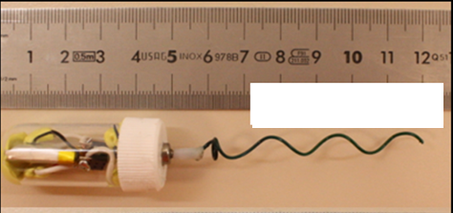
B = 3 mm, N_{λ}=3
(b)
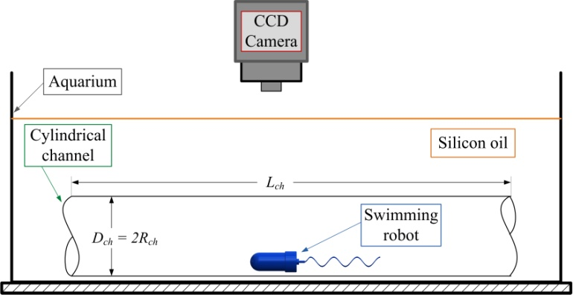
(c)
Fig. 1: Dimensional parameters (a) and layout of the robot with the helical tail of amplitude 3 mm, and having 3 waves (b) and schematic representation of the experimental setup (c).
In the low Reynolds number creeping flow regime, inertial forces are negligible, and incompressible flow is governed by viscous forces balanced by the pressure gradient subject to continuity:
where μ is viscosity, u is the velocity vector and p is pressure.
In the absence of inertial forces, the flow induced by the rotation of the helical tail and the motion of the robot has no memory; instantaneous snapshot solutions of the velocity field and the pressure are obtained from using boundary conditions for the given position of the robot and the helical tail. The centerline position of the wire, which forms a right-handed helical tail, is given by:
where x_{h} is the axial position of the helical tail measured from the joint, B is the amplitude (helical radius), k = 2π/λ is the wave number, λ is the wavelength (helical pitch), and ϕ = ωt is the phase angle that corresponds to the rotation of the helix with angular velocity of ω.

Boundary Conditions
Inlet and outlet of the channel are set to open boundary conditions, i.e. the normal stresses are zero:
.
No-slip boundary conditions are adopted here at the channel walls and on the swimmer's surface. The velocity at the channel wall is set to zero:
The swimming robot moves with a forward velocity, U, while the body and the tail counter-rotate at different rates. Therefore, no-slip moving-wall boundary conditions for the body and the tail are specified as:
and
where r_{sw} is the position of the robot in the z-direction and varied between 0 (centerline) and a value, which corresponds to a small gap between the body and the channel wall; Ω_{b} is the body rotation rate; and ω is the rotation rate of the tail.
The closest distance between the robot and the channel wall is set to 0.1 mm in simulations. Therefore, no slip boundary conditions apply well for experiments that are conducted in cm-scales. Moreover, according to experiments conducted on natural micro swimmers and reported in literature, e.g. [14], electrostatic influences are important when the cells are closer than 20 nm from the surface. The ratio of the length scales based on the proximity of the robots is 5000, hence, results can be deemed applicable for robots with 3.2 µm in diameter swimming in a channel with diameter of 7.2 µm.

Constraint Equations
For the forward velocity of the robot, which is an unknown and specified as a boundary condition in and , the constraint equation for force-free swimming condition is specified as the zero-net force in the swimming direction and obtained from the integration of fluid stresses over the surface of the robot:
where σ is the stress tensor, n_{x} is the x-component of the local surface normal, and is the whole surface of the robot including its tail and body.
Similarly, for the unknown body rotation rate in (6) and (7), zero-net torque constraint is specified as an additional equation:
where are and are (y,z)-coordinates of the joint and n_{(y,z)} are y- and z-components of the surface normal.
Other external forces, such as gravity, magnetic forces and torques, electrostatic forces and random brownian effects acting on the swimmer can be added to free-swim constraints given by and .

Simulation Parameters
Governing equations given by subject to constraint equations and and boundary conditions to are solved with the finite-element method (FEM) software, COMSOL Multiphysics [60]. The finite-element model consists of approximately 90K tetrahedral elements and 450K degrees of freedom. The linear system of equations is solved using the PARDISO direct solver. For each specified position and tail design, phase averaged velocities, forces, torques and efficiencies are obtained from the average of 12 angular positions of the tail varying between π/6 and 2π. In total, 16×8×12=1536 three-dimensional simulations are performed in addition to mesh convergence studies for selected tails and radial positions. Each simulation takes about 3 to 5 minutes on a high end workstation with 12 cores operating at 2.7 GHz and sharing 96 GB or RAM. Fig. 2b shows the mesh distribution when the distance between the robot and the channel wall, w_{d}, equals 0.1 mm with the finest mesh.
In simulations, radial position of each robot in the channel is varied between 0 and 8.9 mm, which is specified only in the z-direction with respect to the centerline of the channel for y = 0 (see Fig. 2). For r_{sw} = 0, the axis of the robot lies on the centerline of the channel, and for r_{sw} = 8.9 mm, the closest distance between the body and the channel wall, w_{d}, is only 0.1 mm. In order to set the position of robot closer than 0.1 mm, restrictive constraints on the finite-element mesh are necessary for accurate solutions. Moreover, as results indicate any further increase in the proximity of the robot to the channel wall does not change the trend in the forward velocity, which should go to zero for the robots that adhere on the wall.

Results
Experiments are performed with fifteen different tail designs with different wavelength and amplitudes to obtain the forward velocity of the robot and the rotation rates of the body and the tail according to the tail parameters. Experimental results are compared with the ones from CFD simulations to validate the CFD model, which is then used to predict the effect of the radial position on the velocity, forces and torques acting on the robot and the efficiency.

Experimental Results
Results from averaging of three experiments for each robot are listed in Table 2. Hydrodynamic models and numerical results indicate that the forward velocity increases with the frequency and amplitude, but has an optimum for the wavelength, which depends on other parameters such as the size of the body and the length of the tail [18, 22, 23, 25, 51]. In the experiments, the frequency of the tail rotation varies according to the torque balance for each tail; therefore theoretical trends are not discernible easily. The rotation frequency of the tail decreases with increasing number of waves and the amplitude due increasing viscous torque. Therefore the tail’s rotation frequency and the forward velocity are at their maximum values for each tail according to the current and power constraints of the battery and the dc motor.

(a)

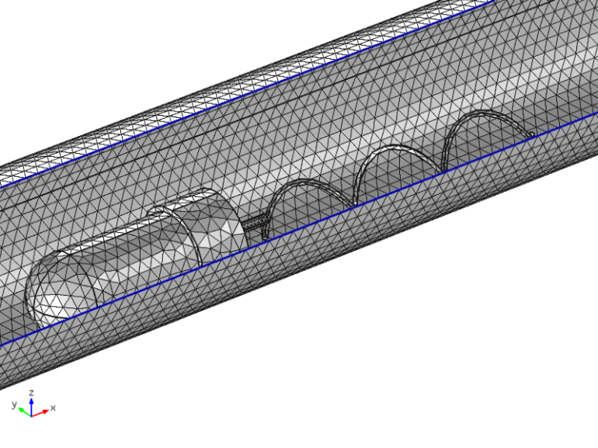
(b)
Fig. 2: (a) The radial position of robot in CFD model is changed along z-axis until the distance between the robot and channel wall, w_{d}, is equal to 0.1 mm. (b)Mesh distribution of the robot having 4 full waves on its tail and B=4mm, traveling near the wall with distance to the wall, w_{d}, equals 0.1 mm.
In the experiments, maximum forward velocity is 1.01 mm/s for the robot with a helical tail that has 3 full waves, 3-mm amplitude, and rotating with the frequency of 2.49 Hz; the minimum forward velocity is 0.32 mm/s for the robot with 6 full waves and 4mm amplitude, for which the tail’s rotation frequency is the smallest as well, 0.89 Hz.
Table II: Experimental results

Robots | Amplitude B, [mm] | Number of Waves, N_{λ} | Rotational frequency of the tail,  ω/2π [s⁻¹] | Forward Velocity of the robot,  U [mm/s] | Rotational Frequency of the body,  Ω/2π [s⁻¹]
R1 | 1 | 2 | 8.19 | 0.68 | 0.049
R2 | 1 | 3 | 4.32 | 0.59 | 0.035
R3 | 1 | 4 | 4.33 | 0.47 | 0.034
R4 | 1 | 6 | 6.13 | 0.56 | 0.043
R5 | 2 | 2 | 3.80 | 0.78 | 0.060
R6 | 2 | 3 | 3.27 | 0.83 | 0.055
R7 | 2 | 4 | 3.14 | 0.96 | 0.057
R8 | 2 | 6 | 2.84 | 0.57 | 0.057
R9 | 3 | 2 | 2.01 | 0.81 | 0.067
R10 | 3 | 3 | 2.49 | 1.01 | 0.065
R11 | 3 | 4 | 2.14 | 0.94 | 0.057
R12 | 3 | 6 | 1.59 | 0.44 | 0.048
R14 | 4 | 3 | 1.18 | 0.97 | 0.063
R15 | 4 | 4 | 1.10 | 0.70 | 0.055
R16 | 4 | 6 | 0.89 | 0.32 | 0.051
The frequency of rotations of tails and bodies vary significantly between robots. Frequency of tail rotations is larger for tails with small amplitudes (between 4.3 and 8.2 Hz for B = 1 mm) than tails with large amplitudes (between 0.9 and 1.2 Hz for B = 4 mm). However, rotational frequency of the body, in principle, is expected to be constant as long as the torque provided by the motor is constant. Variation in body rotation rates could be due to the power-angular velocity relationship of the DC motor [62], and the varying distance between robots and the channel wall; part of the robot’s weight comes from the tail and increases with the actual length of the wire, which increases with the amplitude and the number of helical waves. Furthermore, exact radial positions of robots were difficult to measure in the experiments; it is expected that robots travel as close as possible to the channel wall due to the weight of the tail. Moreover, the adhesion of the robot on the channel wall is not observed in experiments; for all cases, rotation of the body and the forward motion always prevailed.

CFD Results
We used computational fluid dynamics to model the flow and obtain forward velocity and body rotation rate for observed tail rotation rates in experiments for each robot to confirm that the motion of robots is dominated by hydrodynamic effects. In the experiments, it is observed that swimming robot travels near the channel wall due to tail's weight. In the CFD model, the radial position of the swimming robot is varied, and near wall results are used in the validation of the model.

Forward velocity
Experimentally obtained forward velocities are compared with CFD simulation results in Fig. 3. In the experiments, it is observed that swimming robot is moving at the bottom of the channel, but the distance between the channel wall and robots could not be determined.
When the distance between the channel and the robots is 0.1 mm and 0.2 mm, velocity of the robots obtained from simulations agree reasonably well with experimental results, particularly for B = 2 mm, 3 mm, and 4 mm (Fig.3b, Fig.3c, and Fig.3d). When B = 1 mm, simulation results for robots having a distance of 0.2 mm to the channel is in a better agreement than the case for which the distance is 0.1 mm, although the results are very close. Velocities obtained from CFD simulations for the robots travelling near the wall with a clearance of 1 mm are somewhat higher than the velocities obtained in experiments. The velocities are on the order of 1 mm/s, and the fastest robot has 3 full waves on its helical tail with the amplitude (radius of the helix) equals to 3 mm (R10 in Fig.3c).
In the case of one-link swimmer with a helical tail attached to a permanent magnet reported in [50], forward velocity of the swimmers is larger near the wall than at the center of the channel. Furthermore, although a one-to-one comparison with the one-link magnetic swimmer is not applicable because of differences between ratios of dimensions of heads and tails in two cases, the decrease in velocities for B = 4 as N_{λ} increases is similar for both cases.
Analytical studies show that, swimmers with helical tails in unbounded fluids [18, 25] and in cylindrical channels [22] have an optimal value of wavelength that maximizes the swimming speed. Based on an analysis using stokelets, Higdon [25] presented that for the same rotational speed, the optimum number of waves that maximizes the swimming speed is 3 for a swimmer with L/A and a/A equal 10 and 0.02, respectively, where L is the length of the flagellum, A is the radius of the body and a is the radius of the flagellum. Higdon [25] also stated that the optimum number of waves depends strongly on the geometry of the swimmer and the decrease in the swimming speed for number of waves greater than the optimum value is a result of the decrease in the efficiency, since the helical structures lose their slenderness as wavelength decreases.
Optimal number of waves that maximizes the swimming speed depends on the tail geometry as shown in Fig. 3. For B = 2, 3 and 4 mm, optimal numbers of waves are 3, 2 and 1 (last result is according to simulations), respectively.
When B = 1 mm, swimming speed shows a different trend than the rest as rotational frequencies of tail and body are smaller for robots R2 and R3 than R1 and R4. Differences in rotation rates can be attributed to variations in the distance between the robot and the channel wall.
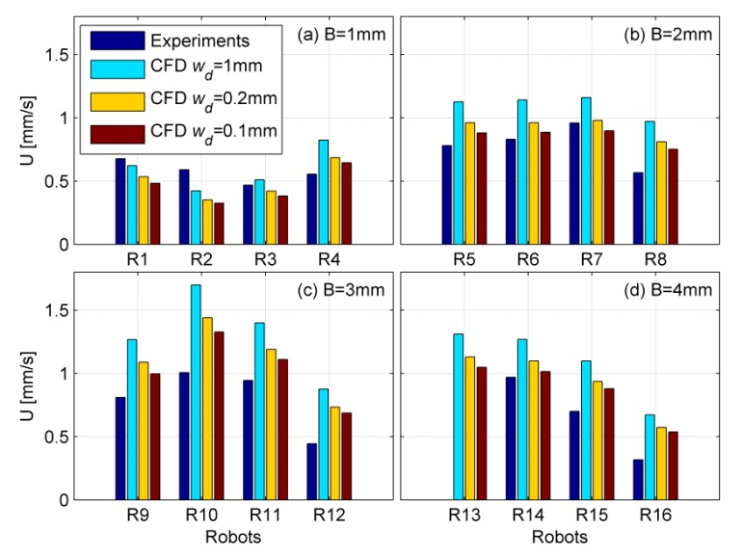
Fig. 3: Velocity of robots, from experiments (navy), from CFD simulations for robots traveling near the wall with distance to wall, w_{d}, equals 1mm (cyan), for robots traveling near the wall with distance to the wall, w_{d}, equals 0.2 mm (yellow), and for robots traveling near the wall with distance to the wall, w_{d}, equals 0.1 mm (red) for amplitudes, B, equals 1 mm (a), 2 mm (b), 3 mm (c) and 4 mm (d).
In Fig.4, forward velocities are normalized with the rotational frequency of the tail to eliminate the effect of the frequency variations on the forward velocity, so that the effect of the amplitude and the wavelength can be identified. In fact, U/f, represents the stroke, which is the distance traveled for a full rotation of the tail. CFD simulations agree very well with experimental results particularly for robots swimming near the channel wall with a distance of 0.1 mm and 0.2 mm especially for B = 2 mm.
According to experiments and near-wall simulations the stroke, U/f, increases with the amplitude. Although the simulation results predict that the U/f increases with N_{λ} for B = 1 mm, experimental results indicate that there is an optimal value of the number of waves on the tail (Fig. 4a). Simulation results agree with the experimentally measured results in predicting that there are optimal values of N_{λ} for B = 2 and 3 mm (Figs. 4b-c), and that U/f decreases with N_{λ} for B = 4 mm (Fig. 4d).
The effect of the radial position on the velocity of the robot is shown in Fig. 5, where the radial position of the swimmer, r_{sw}, is normalized with the channel radius, R_{ch}. For all amplitudes and number of waves, the stroke is higher for robots closer to the wall than the ones at the center up to almost 30%; in particular when the normalized radial position, r_{sw}/R_{ch}, is about 0.4. Similarly, 30% increase in the forward velocity is observed for the one-link swimmer as well for r_{sw}/R_{ch} about 0.5 [63]. This improvement in the forward velocity can be attributed to the reduction in the body resistance coefficient near the wall as discussed in Section B.3.
For radial positions greater than the optimal value that corresponds to the minimum resistance of the body, velocities of robots decrease sharply due to increased shear near the wall; it is plausible that expected velocity of the robot goes to zero when the distance from the wall is below a limit, for which molecular interactions between the robot and the channel wall as observed in experiments with micro organisms [14, 59].
Results also confirm that brownian forces cause more variations for micro structures and organisms swimming near the wall than the ones far away as reported in [17]. Near the wall small changes in the position cause large variations in the velocity, away from the wall since the velocity is fairly uniform, small changes in the position lead to small variations in the velocity.
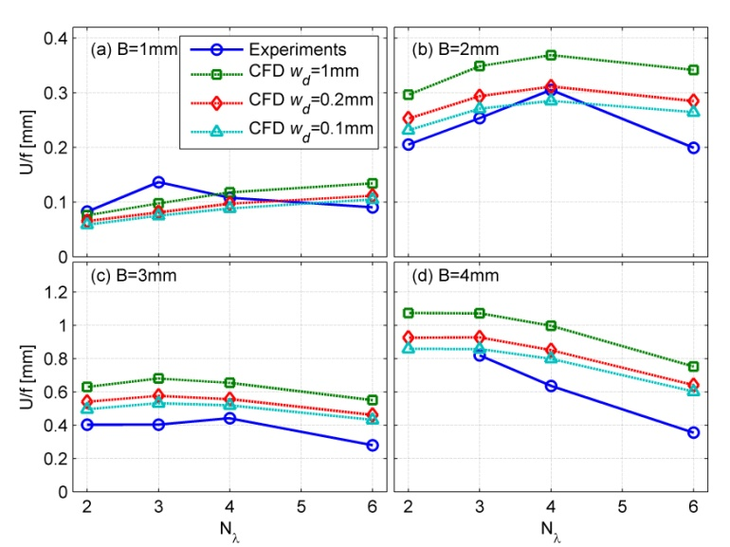
Fig. 4: Velocity of robots are normalized with the rotational frequency of the tail, f. Results are from experiments (‘circles’), from CFD simulations for robots traveling with distance to wall, w_{d}, equals 1mm (‘squares’), for robots traveling with distance to wall, w_{d}, equals 0.2 mm (‘diamonds’), and for robots traveling with distance to the wall, w_{d}, equals 0.1 mm (‘triangles’) for amplitudes, B, equal to 1 mm (a), 2 mm (b), 3 mm (c) and 4 mm (d) and for number of waves, N_{λ},between 2 and 6.
In Fig. 5, it is also observed that the number of waves has a positive effect for B = 1 mm (Fig. 5a), for which the stroke increases with the number of waves for all radial positions; although the increase with the radial position is not as much for N_{λ} = 2 as other values of N_{λ}. For B = 2 mm, the stroke is the highest for all radial positions in the case of N_{λ} = 4, and the lowest for N_{λ} = 2; strokes are almost identical for N_{λ} = 3 and 6 at all radial positions (Fig. 5b). For B = 3 mm, strokes are very similar for all number of waves and radial positions; however the increase in the stroke with the radial position is not as pronounced as other values of N_{λ} than 6 (Fig. 5c). This is also the case for B = 4 mm, for which the stroke for N_{λ} = 6 is significantly lower than others followed by the stroke for N_{λ} = 4, which does not increase as much as it does for N_{λ} = 2 and 3 near the wall (Fig. 5d).
Fig. 5: Simulation results of velocity of the robots are normalized with the wave speed, V = ω/k, as a function of the radial position of the robot for B = 1 mm (a), 2 mm (b), 3 mm (c) and 4 mm (d); and for N_{λ} = 2 (‘square’), 3 (‘downward triangles’), 4 (‘upward triangles’) and 6 (‘diamonds’).
Furthermore, differences between experiments and CFD results in Fig. 4 can be attributed to, in part, the actual radial position of the robot for each tail in the experiments. Although the closest distance to the channel wall is set to 0.1 mm in the simulations, the distance of each robot is expected to vary in the experiments. Therefore, one can conclude that robots travel closer to the channel wall for B = 3 and 4 mm, as experimentally measured velocities are smaller than the ones predicted by the CFD model, since robots slow down as they travel closer to the channel wall as shown in Fig. 5. The interpretation presented here, also agrees with the weight of individual tails that increase with the wire length (curvilinear length) of each tail, which is given by ℓ = [L² + 4π²B²N_{λ}²]^{1/2}, where L is the length of the helix. As the weight of the robot increases due to increasing amplitude and number of waves, the average distance between the robot and the channel wall must decrease.

Body rotation rate
Normalized body rotation rates with respect to angular velocities of tails are compared in Fig. 6. Simulation results indicate that the normalized body rotation rate increases with the number of waves and agree very well with experimental results when the distance from the wall, w_{d}, is between 0.1 and 0.2 mm. Furthermore, for B = 2 mm, simulation results for w_{d} = 0.2 mm agree much better with experiments than the simulation results for the rest do indicates that R5-7 swim not very close to the wall. Simulation and experimental results show that according to the geometry of the tail, the position of robots changes but distance between robot and channel wall is always below 0.2 mm.

Body resistance coefficient
In Fig. 7, the body resistance coefficient, which is the ratio of the axial force on the body to the axial velocity of the robot, F_{x,body}/U, is plotted against the radial position for each robot using the results of the CFD model. As the number of waves and the amplitude of the helical tail increase, body resistance coefficients stay constant for center-swimming as expected, and indicate that tail parameters do not have a significant effect on the body resistance coefficient. However, as the radial position increases, body resistance coefficients decrease to a minimum value where the velocity of the robot almost reaches its maximum (Figs. 5 and 7). As robots get further closer to the channel wall, the body resistance coefficient reaches to the same value as the one at the center of the channel.
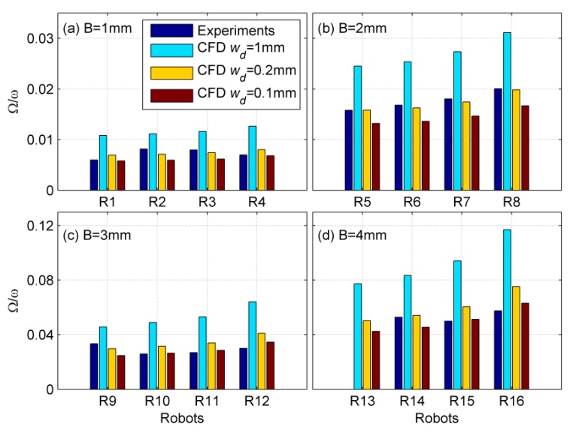
Fig. 6: Body rotation rates are normalized with the angular velocity of the tail, from experiments (navy), from CFD simulations for robots traveling with a distance to wall, w_{d}, equals 1mm (cyan), for robots traveling with a distance to wall, w_{d}, equals 0.2 mm (yellow), and for robots traveling near the wall with distance to the wall, w_{d}, equals 0.1 mm (red) for amplitudes, B, equals 1 mm (a), 2 mm (b), 3 mm (c) and 4 mm (d).
Fig. 7: Simulation results of body resistance coefficients of the robots with respect to the radial position of the robot for B = 1 mm (a), 2 mm (b), 3 mm (c) and 4 mm (d); and for N_{λ} = 2 (‘square’), 3 (‘downward triangles’), 4 (‘upward triangles’) and 6 (‘diamonds’).
For all amplitudes and number of waves, the body resistance coefficient takes a minimum value for the normalized radial position of about 0.4. According to Happel and Brenner [64], resistance of a small sphere traveling inside a cylindrical channel reaches its minimum value for normalized radial position nearly equals to 0.3 at low Reynolds numbers confirming the advantage of off-center swimming.

Radial force and torques
Since the force-free swimming condition is applied only in the x-direction and the motion of the robot is restricted in other directions, resulting forces acting on the robot along the radial direction (i.e. the negative z-direction for y = 0) are presented in Fig. 8 as a function of the radial position. As the number of waves on the helical tail and the amplitude increase, there is not a clear indication of a net radial force on the robot for r_{sw}/R_{ch} values between 0 and 0.3. Occasional variations are attributed to lower order of accuracy in the calculation of forces than the accuracy in the calculation of the velocity [60, 65]; force calculations are based on the stress tensor, which uses derivatives of velocity components, which are projected on to second-order polynomials in the finite-element representation. In order to ameliorate the problem finer mesh than the one used in the simulations is necessary; however for the three-dimensional simulations presented here, any further improvement in the finite-element mesh remains too restrictive, and is not critical for the purposes of this work.
Tail parameters do not have a significant effect on the radial force. As the robot gets closer to the wall, radial force increases first up to w_{d} = 0.2 mm, then a sudden fall and change of direction is observed in Fig. 8 for all amplitudes and wavelengths. Very close to the wall, i.e. w_{d} = 0.1 mm, the z-direction force becomes negative, i.e. the radial force is positive, indicating a push towards the wall due to hydrodynamic effects only, when the robot is parallel to the channel’s axis. Based on this result and the weight of the robot, adhesion of the robot on the channel walls is expected, but not observed in experiments. The deviation can be attributed to the effect of the orientation of the robot, a pitch angle, or a yaw angle, with respect to the surface, may play an important role in the magnitude and the direction of the radial force when the robot is very close to the wall. The increase in the z-direction force is also observed for the one-link magnetic swimmer in [63] but the sudden fall is not observed.
Since the body and the tail counter-rotate, lateral forces on each link occur in opposite directions. Net positive y-direction (also the tangential direction) force indicates that the rotation of the tail dominates the force due to the rotation of the head (Fig. 8e - values are not shown here).
Torques acting on the swimming robot are calculated in CFD simulations and presented in Fig. 9. As the number of waves and the amplitude increase, magnitude of the torque along the z-direction also increases between r_{sw}/R_{ch} = 0 and 0.45. As the distance from the wall decreases further, magnitude of the z-torque decreases. The difference between the z-torque values of robots having different number of waves on the helical tail becomes discernible as the amplitude of the helical wave increases (Fig. 9d). In all cases, robots having tails with 6 waves are affected the most from the net negative z-torque consistent with experiments (Fig. 9f). Lastly, a small positive y-direction torque is observed for all cases (not shown here) indicating that the body pushes itself away from the wall (see Fig. 9e), leading to a positive pitch angle as suspected in the behavior of the radial force near the wall.
Fig. 8: Radial force on z-direction of the robots as a function of the radial position of the robot for B = 1 mm (a), 2 mm (b), 3 mm (c) and 4 mm (d); and for N_{λ} = 2 (‘square’), 3 (‘downward triangles’), 4 (‘upward triangles’), 6 (‘diamonds’) are obtained from simulations and schematic representation of forces acting on the robot swimming near the wall (e).
Fig. 9: Torque on z-direction of the robots as a function of the radial position of the robot for B = 1 mm (a), 2 mm (b), 3 mm (c) and 4 mm (d); and for N_{λ} = 2 (‘square’), 3 (‘downward triangles’), 4 (‘upward triangles’), 6 (‘diamonds’) are obtained from simulations, schematic representation of torques acting on the robot swimming near the wall (e) and top-view of the swimming robot from the experiments (f).

Efficiency
Efficiency of swimming robots is calculated from the ratio of the rate of work done to move the robot in the swimming direction and the rate of work done to rotate the tail, as defined by Purcell for low Reynolds number swimmers [2]. The net force on the robot in the direction of its motion is zero, thus only the drag force on the body is considered for the work done in the swimming direction, as also adopted in other studies for the definition of the efficiency of micro swimmers [18, 25]. The net rate of work done by the rotation of the tail is calculated from the net angular velocity of the tail with respect to the body. Thus, the efficiency of swimming robots is obtained from:
(9)
Here U is the forward velocity, σ is the stress tensor, n_{x} is the x-component of the surface normal, T_{x} is the rotational torque acting on the body in the x-direction, ω is the angular velocity of the tail and Ω_{b} is the angular velocity of the body.
Efficiencies of swimming robots are shown in Fig. 10. For B = 1 mm, the efficiency of the robot increases with the number of waves on the tail and varies slightly with respect to the radial position of the robot: it increases with the radial position of the robot up to a maximum around 0.1% for N_{λ} = 6 near the wall, then decreases with the further increase of the radial position (see Fig. 10a).
For B = 2 mm, there is a significant increase in the efficiency of the robot, compared to B = 1 mm, about 0.35% near the wall for N_{λ} = 3 or N_{λ} = 4, for which the efficiency is significantly larger than for N_{λ} = 6 (see Fig. 10b). For B = 2 mm, number of waves (helical turns) that leads to the least efficient design is 2. The effect of the radial position on the efficiency is clearly visible: there is an optimal position for robots for about r_{sw}/R_{ch}= 0.44 (i.e. w_{d} = 1 mm).
For B = 3 and 4 mm (Fig. 10c and 10d), efficiencies are larger than for B = 1 and 2 mm; about 0.6% for B = 3 mm and almost 1% for B = 4 mm. For N_{λ} = 6, efficiency remains almost constant with respect to the amplitude and with the radial position of the robot. For B = 3 mm, most efficient designs have N_{λ} = 2, 3 and 4 with slight changes in values, and a cross-over between the values at the center and near the wall for N_{λ} = 2 and 4: the former is slightly more (less) efficient at the center than the latter at the center (near the wall) as shown in Fig. 10c.
Although the difference between N_{λ} = 2 and 3 is still very small, the distinction between the efficiencies of robots with N_{λ} = 2, 3 and 4 is clearer for B = 4 mm. However, robots with N_{λ} = 2 is clearly more efficient than for N_{λ} = 3, 4 and 6 in decreasing order especially near the wall where the efficiency is almost 1% (Fig. 10d). Lastly, the effect of the radial position is very small for the robot with N_{λ} = 6: the efficiency remains unchanged for all positions except very close to the wall, for which the efficiency exhibits a decline as the radial position increases.
Overall, the pattern indicates that efficiency increases with the wave amplitude (radius) of helical tails. However, the number of waves has a nonlinear effect: larger number of waves for small amplitudes leads to higher efficiencies, and vice versa. Moreover, the efficiency is consistently larger for robots traveling near the wall than the ones traveling at the center.

Conclusion
In this study, experimental and simulation results are presented for cm-scale autonomous swimming robots inside a viscous-fluid filled channel to mimic the swimming of micro robots in aqueous solutions inside blood vessels and other conduits. A computational fluid dynamics (CFD) model is used to solve three-dimensional Stokes equations that govern the flow, and validated with experiments. Forward swimming and body-angular velocities of the robots are measured in experiments and compared with CFD model results for the same robots traveling at radial positions that vary between the center of the channel and 0.1 mm away from the wall in order to understand the effect of the radial position inside the channel. Simulation results for robots swimming near the wall agree very well with experimental results, where the robots swim very near the wall in experiments as well.
Fig. 10: Efficiency of the robots with respect to the radial position of the robot for B = 1mm (a), 2 mm (b), 3 mm (c) and 4 mm (d); and for N_{λ} = 2 (‘square’), 3 (‘downward triangles’), 4 (‘upward triangles’) and 6 (‘diamonds’) with the results are obtained from simulations.
Swimming velocity and the efficiency of robots peak at a radial position, which corresponds to 1 mm distance from the wall for all wave amplitudes and number of waves; almost 25% increase in the efficiency is observed for the robot with B = 4 mm and N_{λ} = 2 and traveling near the wall, compared to the one with the same parameters traveling at the center of the channel. Efficiency of the robots increases with the amplitude; however the effect of the wavelength is nonlinear: small wavelengths have higher efficiency at small amplitudes, or vice versa.
Body resistance coefficients of the robots are calculated in CFD simulations, according to which the resistance coefficients decreases with the radial position of the robots up to almost 25% near the wall, compared to the value at the center. Furthermore, the tail parameters, namely the amplitude and wavelength, have a small effect on the body resistance coefficient of the swimming robots, which have significantly larger bodies compared to tails.
The radial force on the robot is negligible in the core region of the channel, slightly negative towards the center for the robots closer to the wall before it changes sign and sharply increases when the robot is very close to the wall. The pull towards the wall can combine with the gravity and increases the proximity of the robot to the channel wall leading to its adhesion; however this is not observed in experiments. There is a slight y-torque that indicates the robot may travel with a small pitch angle, which may have an effect on the radial force. It is part of our ongoing efforts to identify the role of orientation of the robot in the channel.
Results provide valuable insight for the design of micro robots for in vivo operations inside vessels, arteries and similar body conduits. Swimming velocities of the robots strongly depend on the geometry of the channel as well as amplitude and the wavelength of the helical tail as well as the radial position of the robot.

References
[1] B. J. Nelson, I. K. Kaliakatsos, and J. J. Abbott, “Microrobots for minimally invasive medicine,” Annual Review of Biomedical Engineering, vol. 12, pp. 55–85, August 2010.
[2] E. M. Purcell, "Life at low Reynolds Number," American Journal of Physics, 45 (1), 3-11, 1976.
[3] J. P. Armitage and R. M. Macnab, "Unidirectional, intermittent rotation of the flagellum of Rhodobacter sphaeroids," Journal of Bacteriology, vol. 169, no. 2, pp. 514-518, 1987.
[4] T. Atsumi, Y. Maekawa, T. Yamada, I. Kawagishi, Y. Imae, and M. Homma, "Effect of viscosity on swimming by the lateral and polar flagella of Vibrio alginolyticus," Journal of Bacteriology, vol. 178, no. 16, pp. 5024-5026, 1996.
[5] H. C. Berg, Random Walks in Biology, Princeton, New Jersey, USA: Princeton University Press, 1993.
[6] B. Behkam, M. Sitti, “Bacterial flagella-based propulsion and on/off motion control of microscale objects,” Appl. Phys. Lett., vol. 90, no. 2, 2007.
[7] S. Martel, M. Mohammadi, O. Felfoul, Z. Lu and P. Poouponneau, "Flagellated magnetotactic bacteria as controlled MRI-trackable propulsion and steering systems for medical nanorobots operating in the human microvasculature," The International Journal of Robotics Research, vol. 28, no. 4, pp. 571-582, 2009.
[8] S. Martel, “Bacterial microsystems and microrobots,” Biomed. Microdevices, vol. 14, pp. 1033-145, 2012.
[9] H.C. Berg, L. Turner, “Chemotaxis of Bacteria in Glass Capillary Arrays” Biophys J, 58, 919, 1990.
[10] Z. Liu, K.D. Papadopoulos, “A Unidirectional Motility of Escherichia coli in Restrictive Capillaries,” Appl. Environ. Microbiol., vol. 61, no. 10, pp. 3567-3572, 1995.
[11] S.A. Biondi, J.A. Quinn, H. Goldfine, “Random motility of swimming bacteria in restricted geometries”, AIChE Journal, vol. 44, no.8, pp.1923-1929, 1998.
[12] W.R. DiLuzio, L.Turner, M.Mayer, P.Garstecki, D.B. Weibel, H.C. Berg, G.M. Whitesides,"Escherichia coli swim on the right-hand side," Nature, 435,30, pp. 1271-4, June 2005.
[13] J. Maennik, R. Driessen, P. Galajda, J. E. Keymer, and C. Dekker, "Bacterial growth and motility in sub-micron constrictions," Proc. Natl. Acad. Sci. PNAS, vol. 106, no. 35, pp. 14861-14866, 2009.
[14] M. A.-S. Vigeant, R. M. Ford, M. Wagner, and L. K. Tamm, "Reversible and irreversible adhesion of motile Escherichia coli cells analyzed by total internal reflection aqueous fluorescence microscopy," Applied and Environmental Mcirobiology vol. 68, no. 6, pp. 2794-2801, 2002.
[15] E. Lauga, W. R. DiLuzio, G. M. Whitesides, and H. A. Stone, “Swimming in circles: motion of bacteria near solid boundaries,” Biophysical Journal, Vol.90, pp. 400-412, 2006.
[16] G. Li, L.-K. Tam, and J. X. Tang, "Amplified effect of Brownian motion in bacterial near-surface swimming," Proc. Natl. Acad. Sci. PNAS, vol. 105, no. 47, pp. 18355-18359, 2008.
[17] M. R. Edwards, R. W. Carlsen, and M. Sitti, "Near and far-wall effects on the three-dimensional motion of bacteria-driven microbeads," Applied Physics Letters, vol. 102, pp. 143701-4, 2013.
[18] S. J. Lighthill, Mathematical Biofluiddynamics.Society for Industrial and Applied Mathematics, 1975.
[19] E. Lauga and T. R. Powers, "The hydrodynamics of swimming microorganisms," Reports on Progress in Physics, vol. 72, pp. 1-36, 2009.
[20] B. U. Felderhof, "Swimming at low Reynolds number of a cylindrical body in a circular tube," Physics of Fluids, vol. 22, pp. 1136041-6, 2010.
[21] L. Arcese, M. Fruchard, and A. Ferreira, “Endovascular magnetically guided robots: navigation modeling and optimization,” IEEE Trans. on Biomedical Engineering, vol. 54(4), pp. 977-987, December 2011.
[22] T. Goto, S. Masuda, K. Terada, and Y. Takano, "Comparison between observation and boundary element analysis of bacterium swimming motion," JSME International Journal Series C Mechanical System, Machine Elements and Manufacturing, vol. 44, no. 4, pp. 958-963, 2001.
[23] M. Ramia, D. L. Tullock, and N. Phan-Thien, "The role of hydrodynamic interaction in the locomotion of microorganisms," Biophysical Journal, vol. 65, no. 2, pp. 775-778, 1993.
[24] H. Shum, E. A. Gaffney, and D. J. Smith, “Modeling bacterial behavior close to a no-slip plane boundary: the influence of bacterial geometry,” Proc. of the Royal Society A, vol. 466, pp. 1725-1748, 2010.
[25] J. J. Higdon, "The hydrodynamics of flagellar propulsion: helical waves," Journal of Fluid Mechanics, vol. 94, no. 2, pp. 331-351, 1979.
[26] D. J. Smith, E. A. Gaffney, J. R. Blake, and J. C. Kirkman-Brown, “Human sperm accumulation near surfaces: a simulation study,” J. Fluid Mech., vol. 621, pp. 289-320, 2009.
[27] E. Lauga, M. P. Brenner, and H. A. Stone, "Microfluidics: The No-Slip Boundary Condition," in Handbook of Experimental Fluid Dynamics (Chapter 19), C. Tropea, A. Yarin, J. F. Foss (Eds.), Springer, 2007.
[28] J. Eijkel, “Liquid slip in micro- and nanofluidics: recent research and its possible implications,” Lab on a Chip, vol. 7, pp. 299-301, 2007.
[29] Y. Zhu and S. Granick, “Limits of the hydrodynamic no-slip boundary condition,” Physical Review Letters, vol. 88, no. 10, 106102(4), 2002.
[30] D. C. Tretheway and C. D. Meinhart, “Apparent fluid slip at hydrophobic microchannel walls,” Physics of Fluids, vol. 14, no. 3, pp. L9-12, March 2002.
[31] C. –H. Choi, K. J. A. Westin, K. S. Breuer, “Apparent fluid slip in hydrophilic and hydrophobic microchannels,” Physics of Fluids, vol. 15, no. 10, pp. 2897-2902, Oct. 2003.
[32] C. Cottin-Bizonne, S. Jurine, J. Baudry, J. Crassous, F. Restagno, and E. Charlaix, “Nanorheology: an investigation of theboundary condition at hydrophobic and hydrophilic interfaces,” The European Physical Journal E, vol. 9, pp. 47-53, 2002.
[33] C. Neto, D. R. Evans, E. Bonaccurso, H. –J. Butt, and V. S. J. Craig, “Boundary slip in Newtonian liquids: a review of experimental studies,” Reports on Progress in Physics, vol. 68, pp. 2859-2897, 2005.
[34] C. D. F. Honig and W. A. Ducker, “No-slip hydrodynamic boundary condition for hydrophilic particles,” Physical Review Letters, vol. 98, 028305, Jan. 2007.
[35] G. Karniadakis, A. Beskok, and N. Aluru, Microflows and Nanoflows: Fundamentals and Simulation, Springer, 2005.
[36] D. R. Absolom, L. A. Hawthorn, and G. Chang, “Endothelialization of polymer surfaces,” Journal of Biomedical Materials Research, vol. 22, pp. 271-285, 1988.
[37] P. B. van Wachem, T. Beugeling, J. Feijen, A. Bantjes, J. P. Detmers, and W. G. vanAken, “Interaction of cultured human endothelial cells with polymeric surfaces of different wettabilities,” Biomaterials, vol. 6, pp. 403-408, Nov. 1985.
[38] M. C. vanLoosdrecht, J. Lyklema, W. Norde, G. Schraa, and A. J. Zehnder, “The role of bacterial cell wall hydrophobicity in adhesion,” Applied and Environmental Microbiology, vol. 53, no. 8, pp. 1893-1897, Aug. 1987.
[39] D. Daffonchio, J. Thaveesri, and W. Verstraete, “Contact angle measurement and cell hydrophobicity of granular sludge from upflow anaerobic sludge bed reactors,” Applied and Environmental Microbiology,” vol. 61, no. 10, pp. 3676-3680, Oct. 1995.
[40] R. W. Colman, V. J. Marder, A. W. Clowes, J. N. George, and S. Z. Goldhaber, Hemostasis and Thrombosis: Basic Principles and Clinical Practice, Lippincott Williams and Wilkins, 2005.
[41] B. Liu, T. R. Powers, and K. S. Breuer, “Force-free swimming of a model helical flagellum in viscoelastic fluids,” PNAS, vol. 108, no. 49, pp. 19516-19520, Dec. 2011.
[42] L. Zhang, J. J. Abbott, L. Dong, K, Peyer, B. E. Kratochvil, H. Zhang, C. Bergeles and B. J. Nelson, "Characterization of the swimming properties of artificial bacterial flagella," Nano Letters, vol. 9, no. 10, pp. 3663-3667, 2009.
[43] A. Ghosh and P. Fischer, "Controlled propulsion of artificial magnetic nanostructured propellers," Nano Letters, vol. 9, no. 6, 2009.
[44] H. Ishihara, F. Arai, T. Fukuda, “Micro mechatronics and micro actuators,” IEEE/ASME Trans.on Mechatronics, vol. 1, no. 1, 1996.
[45] P.K. Kundu, I.M. Cohen, Fluid Mechanics, 4th ed., Academic Press, 2008.
[46] B. Behkam and M. Sitti, "E. Coli inspired propulsion for swimming microrobots," presented at the ASME International Mechanical Engineering Congress and Exposition, IMECE2004, California, USA, November 13-19, 2004, Paper no. IMECE2004-59621, pp. 1037-1041.
[47] T. Honda, K. I. Arai, and K. Ishiyama, "Microswimming mechanisms propelled by external magnetic fields," IEEE Transactions on Magnetics, vol. 32, pp. 5085-5087, Sept., 1996.
[48] M. J. Kim, J. C. Bird, A. J. Van Parys, K. S. Breuer, and T. R. Powers, “A macroscopic scale model of bacterial flagellar bundling,” PNAS, vol. 100, no. 26, pp. 15481-15485, Dec. 2003.
[49] M. J. Kim, M. J. Kim, J.C. Bird, J. Park, T. R. Powers, and K. S. Breuer, “Particle image velocimetry experiments on a macro-scale model for bacterial flagellar bundling,” Experiments in Fluids, vol. 37, pp. 782-788, 2004.
[50] F. Z. Temel and S. Yesilyurt, "Magnetically actuated micro swimming of bio-inspired robots in mini channels," Proc.of the IEEE International Conference on Mechatronics, ICM2011, Istanbul, Turkey, April 13-15, 2011, Paper IF-007366.
[51] F.Z.Temel and S. Yesilyurt, “Simulation-based analysis of micro-robots swimming at the center and near the wall of circular channels,” Microfluidics and Nanofluidics, vol. 14, no. 1-2, pp. 287-298, 2012.
[52] A. G. Erman and S. Yesilyurt, "Swimming of onboard-powered autonomous robots in viscous fluid filled channels," Proc. of the IEEE International Conference on Mechatronics, ICM2011, Istanbul, Turkey, April 13-15, 2011, Paper IF-007633.
[53] S. Tottori, L. Zhang, F. Qiu, K.K. Krawczyk, A. Franco-Obregon, B.J. Nelson, “Magnetic Helical Micromachines: Fabrication, Controlled Swimming, and Cargo Transport”, Adv. Mater., 24, 811-816, 2012.
[54] F. Z. Temel, “Design, Characterization and Visualization of Swimming Micro Robots in Channels,” PhD Dissertation, Faculty of Engineering and Natural Sciences, Sabanci University, Istanbul, 2013.
[55] L. Zhu, E. Lauga, and L. Brandt, "Low-Reynolds number swimming in a capillary tube," J. Fluid Mech., vol. 726, pp. 285-311, 2013.
[56] G. K. Batchelor, An Introduction to Fluid Dynamics, Cambridge University Press, 1967, 1973, 2000.
[57] J.J.L. Higdon and G.P. Muldowney, "Resistance functions for spherical particles, droplets and bubbles in cylindrical tubes," J. Fluid Mech., vol. 298, pp. 193-210, 1995.
[58] H. Bruus, Theoretical Microfluidics, Oxford Master Series in Condensed Matter Physics, Oxford University Press, 2008.
[59] J.D. Klein, A.R. Clapp, R.B. Dickinson, "Direct measurements of interaction forces between a single bacterium and a flat plate," J. Colloid. Int. Sci., vol. 261, pp. 379-385, 2003.
[60] COMSOL AB, Comsol Multiphysics Modeling Guide, 2012.
[61] S. Vogel, Life in Moving Fluids: The Physical Biology of Flow, Princeton University Press, 1994.
[62] A. F. Tabak and S. Yesilyurt, “Experiments on in-channel swimming of an untethered biomimetic robot with different helical tails,” 4th IEEE RAS & EMBS International Conference on Biomedical Robotics & Biomechatronics (BioRob 2012), USA: IEEE 2012, pp. 556-561.
[63] F.Z. Temel, O. Erin, A.F. Tabak, S. Yesilyurt, “Bio-inspired micro robots swimming in channels,” in Proc. of the 13th Mechatronics Forum International Conference (Mechatronics 2012), Linz, Austria, September 17-19, 2012.
[64] J. Happel and H. Brenner, Low Reynolds number hydrodynamics: with special applications to particulate media, Springer, 1973.
[65] O.C. Zienkiewicz, R.L, Taylor, The finite element method: Its basis and fundamentals, Elsevier, 2005.
FatmaZeynepTemel (M’10) was born in Eskisehir, Turkey in 17.01.1984. She received her bachelor degree in mechanical engineering from Istanbul Technical University, Turkey, in 2005, and master degree in mechatronics engineering from Siegen University, Germany, in 2009. Currently, she is working on her Ph.D. in Mechatronics Program, Sabanci University, Istanbul, Turkey.
AydekGokceErmanwas born in Izmir, Turkey in 25.02.1985. She received her bachelor and master degrees in mechatronics engineering from Sabanci University, Turkey, in 2009 and 2011, respectively. Currently, she is working as calibration engineer in Ford Otosan, Istanbul, Turkey.
Serhat Yesilyurt(M’02–SM’11) received his B.S. in nuclear energy engineering from Hacettepe University in Ankara, Turkey in 1986, M.S. and Ph.D. degrees in Nuclear Engineering from MIT in Cambridge, Massachusetts, USA, in 1991 and 1995 respectively. He is a faculty member at Sabanci University in Istanbul, Turkey. His current research interests include microfluidics, micro-swimming robots, and PEM fuel cells.

Manuscript received July 10, 2012. This work was supported in part by the Technological and Scientific Research Council of Turkey (TUBITAK) under the grant number 111M376. F. Z. Temel is with the Mechatronics Program, Sabanci University, Istanbul, Turkey (e-mail: zeyneptemel@sabanciuniv.edu). A.G. Erman, was with Sabanci University, Istanbul, Turkey. (e-mail: gokceerman@sabanciuniv.edu). S. Yesilyurt is with the Mechatronics Program, Sabanci University, Istanbul, Turkey (corresponding author, phone: 90-216-483-9579; fax: 90-216-483-9550; e-mail: syesilyurt@sabanciuniv.edu).

