COMPARISON OF A WIND TURBINE FARM
IN EASTERN MEDITERRANEAN TURKEY
WITH THE PROPOSED AKKUYU NUCLEAR POWER PLANT
IN TERMS OF EFFICIENCY, COSTS AND TOURISM IMPACTS
Veli Kıvanç Temel, Serhat Yeşilyurt
Abstract
This paper compares a wind turbine farm in Eastern Mediterranean Region of Turkey with the proposed Akkuyu Nuclear Power Plant in the same region. In this paper, GE 2.5MW-103 wind turbine was examined in the aspects of efficiency, power, costs and environmental and safety impacts. The best way to obtain the maximum power from a wind farm is to build the wind farm on a hill or mountain rather than offshore or urban areas, since the maximum wind speed can be obtained in the mountains in the Eastern Mediterranean Region. A GE 2.5MW-103 wind turbine on the mountains will be expected to produce around 1.6MW power, though comparing with a nuclear power plant, the electricity generated from a wind turbine is relatively low. A wind farm capable of generating the same electricity with a nuclear power plant should contain 9000 wind turbines and cover 23.5% of the Mediterranean Region of Turkey. Building a wind farm of that size will require 40 billion Euros for 25 years of operation while the nuclear power plant will require the same amount for 60 years of operation. One of the biggest concerns of using nuclear energy is its impacts on tourists, since tourism is an important source of income for Turkey. Although major disasters seem to affect tourism and the region vastly, there are only few disasters and chances for another one to happen are very unlikely if everything is done correctly. The minor incidents on the other hand have no known effects on tourism.

Keywords: wind energy, nuclear energy, efficiency analysis, impacts on tourism

1. Introduction

Due to developing countries continue their growth, their demand for energy constantly increases. Turkey, as well, can be considered as developing country with forthcoming problems in generating electricity. Ongoing industrialization, increasing population and investments to compete with developed countries caused Turkey’s energy demand to burst. However, this burst in energy demand may cause Turkey’s dependence to foreign countries for electricity generation to increase even further. As of 2011, Turkey’s main electricity source is natural gas power plants with 45.9 percent share [1]. However, since Turkey lacks the required resources for natural gas, the energy is mostly dependent on foreign countries. Therefore, Turkey immediately needs to diversify its energy sources and increase its focus on other energy sources. Currently, two of the most popular debates about energy sources in Turkey are related to wind energy and nuclear energy.

Generating electricity from wind power is a developing concept in Turkey. As of January 2012, wind turbines in Turkey generate a total of 1792.7 MW [2], and Turkey plans to generate at least 20000 MW from wind turbines by 2023 [3]. In the last couple of years, the research on determination of wind energy potential of several regions in Turkey increased vastly [4-6]. However, even if Turkey used its all wind potential, it is impossible for wind power to cover all of Turkey’s energy demands in long term. Therefore, nuclear energy is another option for Turkey in order to decrease the imported energy sources. One of the ongoing projects is the Akkuyu Nuclear Power Plant, which is in the Mediterranean Region of Turkey. The Akkuyu Nuclear Power Plant will be Turkey’s first and only nuclear power plant, with a capacity of generating 4800 MW [7-8]. The nuclear power plant is planned to start its first operation in 2019 and it will cover eight percent of Turkey’s energy demand in 2020 [9].

The main objective of this study is to compare a wind farm in the Mediterranean Region of Turkey with the proposed Akkuyu Nuclear Power Plant. In the course of the research, the required capacity of a wind farm to supply the electricity needs of an industrial area will be calculated. Additionally, the paper will examine whether a wind turbine farm might be considered as an alternative to proposed Akkuyu Nuclear Power Plant. While comparing both, the paper will also calculate the size of a wind farm to match the generated electricity of a nuclear power plant, and look at the touristic impacts of a nuclear power plant on the region that it is being built, since the area of the proposed Akkuyu Nuclear Power Plant is close to locations with touristic value.

2. Feasibility of the Wind Farm

2.1. Efficiency Analysis
Energy of the wind cannot be converted completely to mechanical energy, which is explained by Betz’ Law [10]. Due to the losses caused by drift components, it is impossible to obtain this amount of power. Also, it is impossible to stop the wind and convert all of its energy into another kind of energy, since wind will continue to flow. The theoretical available power to use for energy conversion is 59.3% of the maximum power of the wind, which is also known as the Betz’ Limit. Additional to the drift components of the wind, the efficiency of a wind turbine decreases due to the effects of internal components of the wind turbine. A wind turbine has three main constructed components: blades, nacelle and the tower. Blades are connected to nacelle through a hub and nacelle contains all the power generation parts such as main shaft, gearbox, disk brake, generator and control systems (Fig. 1), where all of them contribute to the losses in efficiency [10].

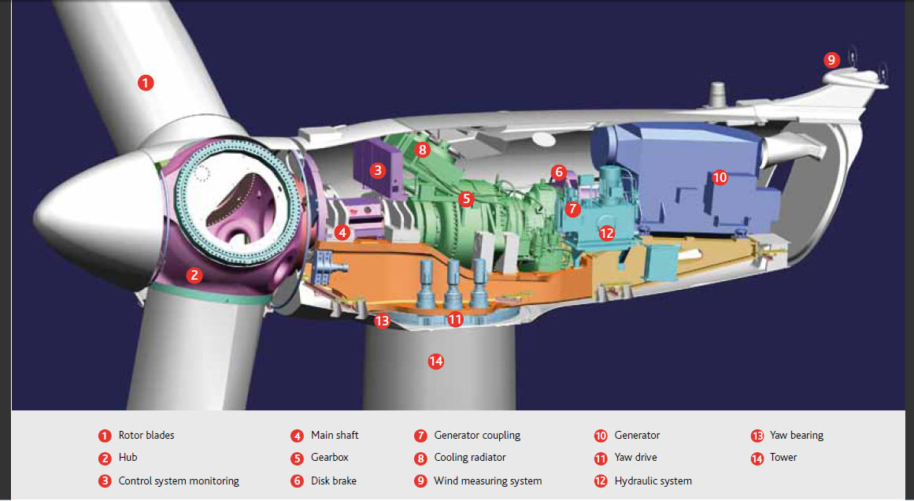
Fig. 1. The view of inner components of the nacelle of a wind turbine (Acciona AW-3000) [11].

The wind turbine farm in Bahçe, Osmaniye – a city in Eastern Mediterranean Turkey, contains 54 GE 2.5MW-100 wind turbines [12]. Therefore, for efficiency analysis, GE 2.5MW-103 will be used since it is possible to have a hub height of 100 meters in GE 2.5MW-103 series and it is similar to the 2.5MW-100 series. Power curve of the wind turbine is shown in Figure 2.2.
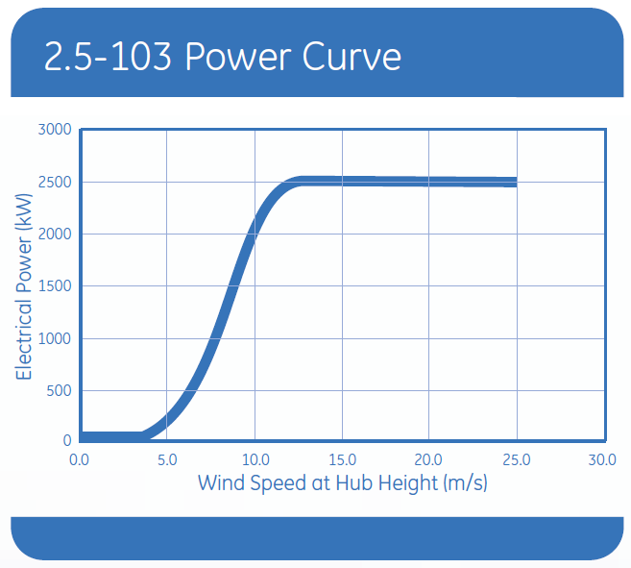
Figure 2. Power curve of GE 2.5MW-103 [13]

The theoretical value of the power that a wind turbine can generate can be found by using;

$${Power}_{wind,generated}=\frac{1}{2}ρAu^{3}*\frac{16}{27}$$ | (1)
where $ρ$ is the density of air, $A$ is the area that is covered by the rotor, $u$ is the wind speed and $\frac{16}{27}$ is the Betz Limit. GE 2.5MW-103 has a rotor diameter of 103 meters, with cut in speed at 3 m/s and cut-off speed at 25 m/s. For 10 m/s wind speed, theoretically a turbine with 103 meter rotor diameter can generate 5.12MW at maximum. When Betz Limit is applied to this value, the maximum available power that the turbine will be able to convert will be equal to 3.04MW. However, according to the power curve of GE 2.5-103 (Figure 2.2) which is given in the product brochure, the rated output electrical power at 10 m/s is around 2 MW. This shows that the efficiency against the Betz Limit is 65.9%, whereas the overall efficiency of the wind turbine at 10 m/s is 39% (Table 1).

Table 1. Efficiency and generated power values of GE 2.5-103 for different wind speeds (left)
Wind Speed (m/s) | Maximum Power (MW) | After Betz Limit (MW) | Measured Power (MW) | Efficency vs Betz Limit (%) | Overall Efficiency (%)
5 | 0,64 | 0,38 | 0,20 | 52,7 | 31,2
6 | 1,11 | 0,66 | 0,40 | 61,0 | 36,2
7 | 1,76 | 1,04 | 0,70 | 67,2 | 39,8
7,5 | 2,16 | 1,28 | 0,90 | 70,3 | 41,7
8 | 2,62 | 1,55 | 1,10 | 70,8 | 41,9
8,5 | 3,15 | 1,86 | 1,35 | 72,4 | 42,9
9 | 3,73 | 2,21 | 1,60 | 72,3 | 42,9
9,5 | 4,39 | 2,60 | 1,80 | 69,2 | 41,0
10 | 5,12 | 3,04 | 2,00 | 65,9 | 39,0
11 | 6,82 | 4,04 | 2,35 | 58,2 | 34,5
12 | 8,85 | 5,24 | 2,50 | 47,7 | 28,2
13 | 11,25 | 6,67 | 2,50 | 37,5 | 22,2
14 | 14,05 | 8,33 | 2,50 | 30,0 | 17,8
15 | 17,29 | 10,24 | 2,50 | 24,4 | 14,5

Figure 3. Total efficiency vs the wind speed (right)

2.2. Power
Power generated from a wind turbine is directly affected with three different variables: the air density, the area that wind goes through and the speed of the wind. To get the maximum power from the wind turbines, the wind farm should be planted to the area with the highest average wind speed, which might be a hill, a mountain or off-shore. According to the wind map of Turkey, a wind turbine planted off-shore in Eastern Mediterranean Region of Turkey will have between 7.5 and 8 m/s wind speed on average. Also, a wind turbine planted on a mountain or a hill in the Eastern Mediterranean Region of Turkey will have between 8.5 and 10 m/s wind speed on average. Using these values, we can calculate the maximum wind power density and the available power. To compute the total available power, the rotor diameter is required since the wind will pass through the area that rotor covers.

The wind energy map of Turkey is shown in Fig. 4, in which Eastern Mediterranean Region of Turkey is colored with yellow indicating that the wind speed at hills and mountains is measured between 8.5 and 10 m/s. A detailed wind speed map of Mediterranean Region at 100 meters can be seen in Fig. 5.

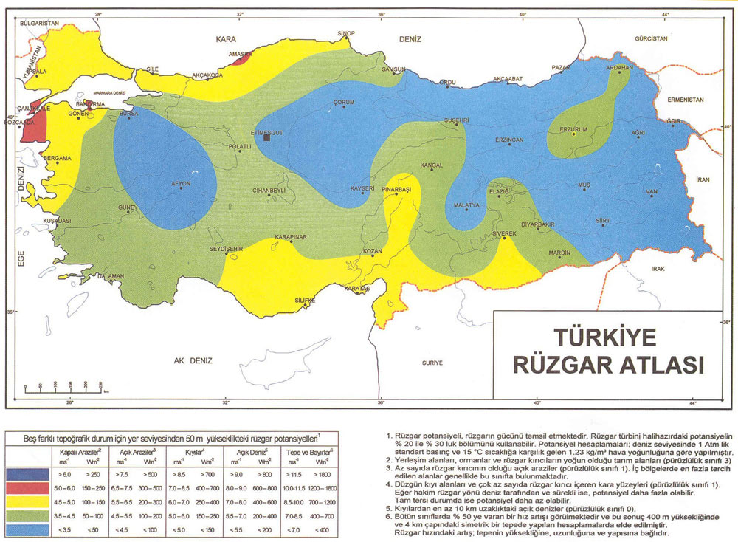
Figure 4. Turkey wind map [15].

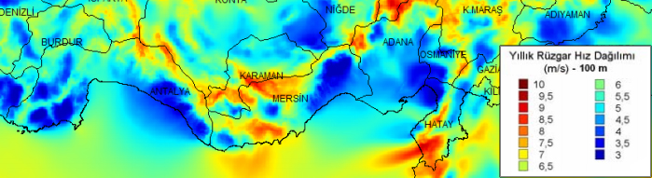
Figure 5. Mediterranean Region wind map [16].

Using these values, it is simple to calculate the total available power of the wind and the estimated generated power.
The wind speed on a hill in Eastern Mediterranean Region will be between 7 and 9.5 m/s. Assuming that the wind speed for the region where wind farm is installed is 9 m/s, the available power will be 3.74 MW and the generated maximum power from the wind turbine will be 1.60 MW, due to the losses stated. This means that a single GE 2.5MW-103 wind turbine on the hills will be expected to generate 1.60 MW.

Although GE 2.5MW-103 on a hill is ideally expected to produce 1.60 MW, that is not the real case. In reality, the capacity factor of the wind farm should also be considered. The capacity factor of a power plant is defined as the ratio between the real generated output power and the calculated output power of a power plant. The capacity factor map of Turkey for 50 meters height was modeled by the Turkish Wind Energy Association and it is shown in Fig. 6. According to the capacity factor map, at 50 meters the best capacity factor was measured on top of the mountains and on offshore.

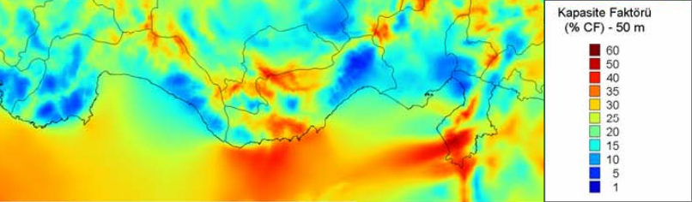
Figure 6. Eastern Mediterranean Region capacity factor map at 50 meters [16]

Although the capacity factor map was modeled for 50 meters height, it is safe to assume that the capacity factor will increase with height as a result of a more consistent wind. At 100 meters, a guess can be made for around 3 to 5% increase in the capacity factor can be expected since wind speed increases slightly. Common values for the capacity factor of a wind turbine are between 20 and 40% [17]. As seen in Fig. 6, a wind turbine installation on the mountains of Eastern Mediterranean Region can expect a capacity factor up to 50%; however, the capacity factor of a wind farm can be expected to be around 30% due to variations of wind speed and capacity factor, as Fig. 5 and Fig. 6 show.

Ideally, a wind farm consisting of 50 GE 2.5MW-103 wind turbines will be able to generate 80 MW at their best. An 80 MW wind farm will be able to generate 700.8 GWh annually and 58.4 GWh monthly. By taking the capacity factor into account and assuming that the capacity factor of the area is 30%, the generated electricity will be around 210.2 GWh annually and 17.5 GWh monthly. The average monthly electricity consumption of Osmaniye Organized Industry Area was around 114 GWh as of September 2010 [18]. So to compare, an 80 MW wind farm will be able to provide 15% of Osmaniye Organized Industry Area’s electricity.

2.3. Cost Analysis
There are many aspects while determining the cost of a wind farm on a hill or mountain. Despite the costs of each wind turbine, there are also land costs, operation and maintenance costs and construction and installation costs. Table 2 shows the cost structure of a typical 2 MW wind turbine in Europe [19]. It is expected that the total investment for a wind turbine will cost around 1.23 million Euros per MW including land costs and installation costs [19]. Using this assumption, a GE 2.5MW-103 will cost around 3.075 million Euros. A wind farm consisting of 50 wind turbines will have an initial cost of 153.75 million Euros. An analysis under the Vindforsk Project in Sweden [20] shows that as hub heights increase, the costs increase as well. For a 3 MW turbine at 100 meter hub height, several tower designs show that the total costs of the turbine is expected to be range between 3.7 and 3.9 million Euros. A 2.5MW turbine will cost less due to the less complexity of the design of hub, so initial assumption of 3.075 million Euros is solid.

Table 2. Cost structure for a 2 MW wind turbine [19]
Type of Cost | Investment (1000€ / MW)
Turbine | 928
Foundations | 80
Electric Installation | 18
Grid Connection | 109
Control Systems | 4
Consultancy | 15
Land | 48
Financial Costs | 15
Road | 11
Total | 1227
The operation and maintenance costs are assumed as 1.2 to 1.5 Euro cents per kWh of the generated power [19]. Annually, the wind farm with 50 wind turbines is expected to produce 210.2 GWh in a year, which will make the annual operation and maintenance costs as 3.15 million Euros. Since a wind turbine has 25 years of life span, this would mean roughly 78.8 million Euros of additional costs, which will make the total cost of a wind farm with 25 years of life span around 232.6 million Euros.

According to the new regulations of Turkish government [21], the price per kWh of wind energy is 7.3 American Dollars cents as of 01/01/2012, which is around 5.67 Euro cents. The wind farm generates 210.2 GWh annually, so the annual revenue of the wind farm will be 11.9 million Euros, and the total revenue in 25 years of life span will be 298.0 million Euros. Since the total cost was expected to be 232.6 million Euros, it will result with a benefit around 65.4 million Euros over 25 years, which makes the investment to a wind farm feasible and attractive.

2.4. Environmental and Safety Impacts
Using wind as an energy source is one of the cleanest ways to provide the necessary energy to meet the requirements. Unlike the power plants using carbon-based fuels, wind turbines do not emit any pollutants such as carbon dioxide, sulfur oxide and nitrogen oxide [19]. This aspect of wind turbines makes it a desirable energy source in order to stop the global warming and producing electricity at the same time. A power plant using coal will produce 974 tonnes of CO₂ per GWh of electricity produced, while a wind farm will generate between 14 to 34 tonnes of CO₂ per GWh of electricity [22]. Even this characteristic of wind turbines makes it very desirable; however, there are many ongoing debates whether the wind turbines and wind farms causes some environmental impacts as well.

To begin with, the main concern for wind farms is the noise they create. Wind farms are mostly built away from populated areas, since every building after a certain height will disturb the wind and decrease the efficiency of the wind turbine. However, there are still some complaints that the noise that is created by the wind turbines damages the human health. The latest research shows that the wind turbine noises are generally less than a highway or a busy office and it is well below the threshold of pain [23, 24]. Table 3 compares the noise levels of wind farm at 350 meters with other elements. Also, it is not recognized by any organization that a wind farm causes a specific disease or a “wind turbine syndrome” [25]. So, in conclusion, noise would not be a factor for not building a wind farm.

Table 3. Noise Levels Caused by Several Noise Sources [24].
Noise Source / Activity | Indicative Noise Level dB (A)
Rural night-time background | 20-40
Wind Farm at 350m | 35-45
Car at 40 mph at 100m | 55
Busy general office | 60
Pneumatic drill at 7m | 95
Jet aircraft at 250m | 105
Threshold of pain | 140

Secondly, impacts on the wildlife – mainly to flying animals and marine animals in offshore wind farms – is a concern. Most of the wind farms consist of wind turbines with high altitudes and that causes some impact with the flying animals such as birds and bats. It is estimated that wind turbines causes 0.269 mortalities to flying animals per GWh of electricity produced; however, it is still lower than fossil fuel power plants or nuclear power plants – 5.18 and 0.416 respectively – which indirectly causes these fatalities [26]. This issue is mostly related with the planning of the wind farm. Wind farms should be planned so that they are not installed on the bird migration routes or on places where avian animal population is high. By this approach, the odds of affecting the wild life will decrease significantly. Additionally, there is another debate going on for offshore wind farms, which questions whether they affect the marine mammals or not. However, a research on this topic shows that there shouldn’t be any significant effect of offshore wind turbines to marine mammals during their operation, although the construction process of the wind farm may cause some effect [27].

One of the major environmental impacts of wind turbines is that wind turbines need lots of lands to operate without conflicting with each other. Due to safety concerns, wind farms require more land than most of the other energy sources, although these lands can be used for other purposes as well, such as agriculture. In United Kingdom, it is measured that the wind farms occupies only one percent of the total area that they are built on, including the service roads, turbine itself and power stations [19].

There are also some safety impacts of wind turbines as well. Wind farms are not built in urban areas because of less wind potential and other safety risks. These safety impacts can be covered under the following: blade throw, tower failure, falling ice from the blades, fire hazards, worker hazards, generated electromagnetic fields and attractive nuisance of wind turbines [19]. Blades of wind turbines have very high tip speeds: for example Vestas V90-3MW has a tip speed of 252.67 km/h at 11 m/s [28]. If the wind speed exceeds a certain value, normally the brakes will apply to slow down the wind turbine; however, a failure of the brakes will cause the wind turbine to reach extraordinary speeds and it may cause blades to detach from the hub and thrown. Any living creature around the wind turbine will have very high risk of death if this occurs since the blades are very heavy and moving with very high speed. The same applies with tower failure as well. If the tower fails to hold the rotor and the nacelle, it may collapse and may cause damage.

Another safety impact of wind turbines is the falling ice from the blades. At very low temperatures, due to humidity and rain, ice may form on the blades. As the blades rotate, the blades will warm up due to friction, and some of the ice may fall down or thrown by blades and may cause potential risk. This may be prevented by cancelling the operation of wind turbines at low temperatures; however, it will decrease the generated power, so there is a trade-off. There are other safety concerns, such as fire hazards caused by poor installations and connections, and worker hazards that are caused by some carelessness and due to not taking some necessary precautions, but these hazards can be prevented easily.

3. Comparison of Akkuyu Nuclear Power Plant and a Potential Wind Turbine Farm

3.1 Power

A wind turbine is estimated to generate 1.6 MW power, which means a typical wind farm’s electricity generation will be very low value compared to a nuclear power plant. The Akkuyu Nuclear Power Plant is planned to be constructed in Akkuyu, Mersin – which is in the Mediterranean Region of Turkey. The plant will consist of 4 VVER-1200 reactors, which are expected to produce 1200 MW power each. So, in total, the nuclear power plant will generate 4800 MW [7,8], with a capacity factor around 90% [29]. The annual generated electricity by the nuclear power plant is expected to be around 37.8 TWh whereas the annual generated electricity of a wind farm consisting of 50 wind turbines is expected to be 210.2 GWh. A wind farm that is capable of generating the equal amount of electricity that a nuclear power plant generates should contain around 9000 wind turbines where each turbine generates 4.2 GWh annually.

3.2 Lifetime

When lifetimes are compared, a nuclear power plant has twice of life that a wind turbine has. Typically, a wind turbine is expected to have 25 years of lifetime, whereas the VVER-1200 is expected to have 50 or 60 years of lifetime [29]. A wind farm should be renewed completely and installed from beginning to meet up with a nuclear power plant.

3.3 Costs

In the cost analysis of a wind farm, it was found that a typical wind turbine will cost around 1.23 million US Dollars per MW. Therefore, a wind farm capable of generating the same power with Akkuyu Nuclear Power Plant will have an initial investment cost around 27.7 billion Euros. A wind farm is estimated to have an operation time of 25 years whereas Akkuyu Nuclear Power Plant is estimated to have an operation time between 50 and 60 years. Thus, the total equivalent initial investment cost of a wind farm capable of generating the same amount of power with Akkuyu Nuclear Power Plant will be around 55.4 billion Euros. Additionally, the annual maintenance costs of 9000 wind turbines will be around 567 million Euros. Akkuyu Power Plant will have an initial investment cost around 20 billion Euros and annual maintenance costs around 500 million Euros [30, 31].

3.3.1 Area
The land requirements for a wind turbine farm make it not feasible to replace a nuclear power plant completely with a wind turbine farm. Until recently, the distance between each wind turbine in a wind farm was set as 7 rotor diameters. However, recent researches by Meneveau and Meyer showed that for a better cost-efficient turbine and to prevent the effects of turbulence caused by wind turbines on each other, the minimum distance between each wind turbine should be 15 rotor diameters [32].

A GE 2.5MW-103 has a rotor diameter of 103 meters, which means that the distance between each wind turbine should be 1545 meters, according to recent researches. So, 4 wind turbines constructed as a square will occupy a land of 2.39 kilometer squares. A wind farm consisting of 9000 wind turbines will occupy a land of 21092 kilometer squares, 2.5 percent of Turkey and 23.5 percent of Mediterranean Region of Turkey. Even if the distance between two wind turbines were set as 7 rotor diameters, the proposed wind farm will occupy 4593 kilometer squares of land, which is approximately 5.1 percent of the Mediterranean Region of Turkey.

It is nearly impossible to find a land of this size in any region of Turkey for this purpose. Akkuyu Nuclear Power Plant will generate the same electricity on around 5 km² land, which is incomparably small.

3.3.2 Impact on Tourism

One of the biggest concerns of building a nuclear power plant is its effect on tourists. Currently, most of the developed and developing countries are using nuclear energy and initially, building a nuclear power plant will not cause any expectations for a decrease on tourism revenue. Up until now, there are many recorded incidents and accidents, but only a few of them are considered major disasters and have fatalities [33]. However, although the chances are unlikely, the effects of a disaster in a nuclear power plant are enormous. The world experienced three major nuclear disasters in the last 30 years: Three Mile Island, Chernobyl and Fukushima Daiichi. All of them caused huge damages to the economy, surroundings or have severe effects on humans. The latest of these disasters, Fukushima Daiichi nuclear disaster, happened on 11 March 2011 as a result of the tsunami following the earthquake of a magnitude 9.0 [34]

Table 3.1: Total Visitor Arrivals and Percentage Change of Visitors in Japan in years 2010 and 2011 [35]
Month | 2010 |  | 2011
 | Total Visitor Arrivals | % Change | Total Visitor Arrivals | % Change
January | 640,346 | 10,3% | 714,099 | 11.5%
February | 664,982 | 62,7% | 679,398 | 2.2%
March | 709,684 | 24,8% | 352,666 | -50.3%
April | 788,212 | 25,8% | 295,826 | -62.5%
May | 721,348 | 48,5% | 357,783 | -50.4%
June | 677,064 | 59,5% | 432,883 | -36.1%
July | 879,100 | 38,9% | 561,489 | -36.1%
August | 802,725 | 18,1% | 546,503 | -31.9%
September | 717,756 | 34,0% | 538,727 | -24.9%
October | 727,278 | 11,0% | 615,701 | -15.3%
November | 634,818 | 12,3% | 551,571 | -13.1%
December | 648,380 | 3,4% | 572,101 | -11.8%

After, the Tohoku earthquake and Fukushima Daiichi nuclear disaster, tourism in Japan was hit hard. Table 3.1 shows the count of total visitor arrivals in Japan in years 2010 and 2011. After the first three months of the disaster, the tourist count decreased by 50% compared to the previous year. In total, 6.2 million international tourism arrivals were recorded in 2011, which was 28% less than the 8.6 million recorded in 2010 [36]. The government in Japan is discussing ways to promote the country again and the Japan Tourism Agency began to spend millions of dollars to revive tourism again [37] and initial reports are showing that Japan tourism starts to return close to the normal levels.

The proposed Akkuyu Nuclear Power Plant is planned to be built in Mersin in the Mediterranean Region, which is the neighbor city of Antalya, Turkey’s most popular touristic region. In 2011, 10.5 million of the recorded 31 million tourists visited Antalya [38]. Therefore, a possible disaster of the size of Fukushima will affect Turkish tourism enormously. Turkish government declared that the revenue from tourism was 20.8 and 23 billion US Dollars in 2010 and 2011 respectively. If a disaster in the Akkuyu Nuclear Power Plant causes a similar effect to Turkish tourism, the revenue from tourism will decrease by up to 6 billion US Dollars for the first year.

However, the chances of a major disaster are very unlikely and the accidents of that size happen only under extreme conditions. Minor accidents and incidents happen more frequently, however, these accidents are no reported to affect tourism. After a radiation leak to the ocean in the San Onofre Nuclear Plant in California, United States, the surfing society was not affected. As the location was known as a world-class surf spot and the surfers ignored the radiation leak and continued their activities [39]. Additionally, according to a research made for tourism impacts of radioactive waste transport, no major impacts on tourism caused by the various nuclear facilities near tourist destinations were recorded [40]. In the research, it was also stated that after Three Mile Island accident in Pennsylvania, United States, tourist visitation count decreased both in the incident area and the whole state. In the first eight months after the accident, which happened in March 1979, tourist count decreased, reaching the maximum decrease in July 1979 – 41.8% less than the previous year. However, besides these short term effects, the accident did not cause any reported long term effects in the state or the region and on December 1979, the tourist count increased 13.8% with respect to December 1978. Therefore, it is safe to assume that unless there is a major disaster; tourism will not be affected in long term.

On the other hand, wind energy doesn’t face such problems because a malfunction will not cause a regional effect. However, a wind farm that is capable of producing the same power as a nuclear facility will occupy so much space -23.5 percent of the whole Mediterranean region; it might have effects on wild life and cause a decrease in country’s reputation due to environmental movements.

4. Conclusion
Wind energy, with an increasing interest, has a bright future. First of all, wind energy is one of the cleanest energy sources in terms of carbon dioxide emissions. Since the carbon dioxide concentration in air is directly related with global warming, it will significantly decrease the effects of energy sources and power plants on global warming. Secondly, wind farms are generally beneficial. The regulations of Turkish government support wind farms and electricity generated from wind turbines is bought by the government for a reasonable price. These regulations are arranged so that the wind energy market will increase its share on Turkish economy and with these prices; it is easy to earn huge profits from wind farms. The cost analysis showed that it is possible to earn revenues around 25% of the investment in 25 years, which is an attractive aspect of wind energy.

However, wind energy is not comparable with nuclear energy. The analysis showed that in order to build a wind farm producing the same power with Akkuyu Nuclear Power Plant, the wind farm must consist of more than 9000 wind turbines, and will cost more than 40 billion Euros for 25 years of operation, whereas the Akkuyu Nuclear Power Plant is assumed to have a cost around 40 billion Euros for 60 years of operation. On the other hand, a wind farm consisting of 50 wind turbines in the Eastern Mediterranean Region of Turkey will be able to provide 15% of a mid-scaled Organized Industry Area, which consumes around same electricity as a small city.

The concern of nuclear power plants is the possibility of a disaster. The nuclear disasters up until now have damaged the regions and there are many concerns regarding this matter. A disaster in the Akkuyu Nuclear Power Plant will not only cause disruption of many habitable areas around the region, but also affect the tourism that it will damage the country’s economy. These major disasters are rare and the chances of them to happen are unlikely. Small-scaled accidents are more frequent, although in general they didn’t cause many fatalities and radiation leaks and doesn’t result with any effects on tourism. Additionally, a wind farm capable of producing the same output as Akkuyu Nuclear Power Plant may cause the similar effect on tourism, since it requires 9000 wind turbines.

Wind energy also has debates going on for its effects on environment and health and its safety impacts. Common sense among people shows that wind turbines have health impacts on people, especially because of the noise it creates. However, as mentioned before, wind farms don’t generate noise to cause diseases, especially when they are installed outside of urban areas. Effects on wild life are worthy of notice, since a wind farm installed on the migration routes of birds will cause many fatalities and even may result with the extinction of certain species. However, this case may be prevented to some extent by planning the wind farms into locations that will least affect the birds. There are also some safety impacts of wind turbines, nevertheless as mentioned before it is possible to prevent them and minimize the risks, even though the risks are still very low and comparable to other renewable energy sources.

To conclude, both wind energy and nuclear energy must be used in order to stabilize Turkey’s growth and need of electricity. Wind is an energy source that our society must benefit from and with improving technology most of its disadvantages will vanish as well. Although there is an efficiency limit and there are some environmental and safety concerns, wind energy can still be preferred to most of other energy sources – both renewable and non-renewable – because of its benefits such as being clean, ability to gain profits, and its cost being relatively small compared to other energy sources. On the other hand, nuclear energy is the most practical way to cover energy demands of the country, since it requires half the investment with a wind farm producing the same electricity.

References

[1] Elektrik Üretim Anonim Şirketi, "Elektrik Üretim Sektör Raporu," 2011.
[2] EPDK, "Yenilenebilir Enerji Kaynaklarına İlişkin Diğer Bilgiler," January 2012. [Online]. Available: http://www2.epdk.org.tr/lisans/elektrik/yek/yek.html. [Accessed 30 January 2012].
[3] R. Haber, "Rüzgar Enerjisinde Hedef 20 bin megavat," 25 August 2011. [Online]. Available: http://www.risalehaber.com/news_detail.php?id=117804. [Accessed 30 January 2012].
[4] A. Ucar and F. Balo, "Evaluation of wind energy potential and electricity generation," Applied Energy, no. 86, pp. 1864-1872, 2009.
[5] B. Sahin, M. Bilgili and H. Akilli, "The wind power potential of the eastern," Journal of Wind Engineering and Industrial Aerodynamics, no. 93, pp. 171-183, 2005.
[6] C. İlkiliç and İ. Türkbay, "Determination and utilization of wind energy potential for Turkey," Renewable and Sustainable Energy Reviews, no. 14, pp. 2202-2207, 2010.
[7] "VVER," March 2011. [Online]. Available: http://en.wikipedia.org/wiki/VVER#VVER-1200. [Accessed January 2012].
[8] Türkiye Atom Enerjisi Kurumu, "Akkuyu'da Kurulması Düşünülen VVER-1200 Tipi Nükleer Santral," 25 October 2010. [Online]. Available: http://www.taek.gov.tr/component/content/article/194-nukleer-enerji-ve-nukleer-reaktorler/801-akkuyuda-kurulmasi-dusunulen-vver-1200-tipi-nukleer-santral-yeni-bir-teknolojidir-dunyada-hicbir-yerde-uygulanmamistir-rusyada-da-iki-yerde-gelistirilecektir-yap. [Accessed 2 January 2012].
[9] M. A. Ajansi, "Akkuyu santrali, Türkiye'nin enerji ihtiyacının yüzde 8'ini karşılayacak," Zaman Ekonomi, 16 August 2011. [Online]. Available: http://www.zaman.com.tr/haber.do?haberno=1169496. [Accessed 30 January 2012].
[10] A. V. Da Rosa, Fundamentals of Renewable Energy Processes, California: Academic Press, 2009.
[11] "Acciona Windpower AW-3000," [Online]. Available: http://www.acciona-energia.com/media/294147/aw3000.pdf. [Accessed December 2011].
[12] T. Huyuk, C. Toplar and B. Savas, "Environmental and Social Impact Assesment for the Bahce Wind Farm Project," Zorlu, Ankara, 2009.
[13] "GE Power and Water Renewable Energy - 2.5 MW Wind Turbine Series," 2010. [Online]. Available: http://www.ge-energy.com/content/multimedia/_files/downloads/GEA17007A-Wind25Brochure.pdf. [Accessed December 2011].
[14] L. Devlin, "Wind Turbine Efficiency," 15 November 2007. [Online]. Available: http://k0lee.com/2007/11/wind-turbine-efficiency/. [Accessed January 2012].
[15] Devlet Meteoroloji Isleri, Türkiye Rüzgar Atlası.
[16] Malkoç, Y. (2007). Türkiye Rüzgar Enerjisi Potansiyeli ve Enerji Profilimizdeki Yeri. Ankara: EİE İdaresi Genel Müdürlüğü, Türkiye Rüzgar Enerjisi Birliği.
[17] University of Massachusetts at Amherst, "Wind Power: Capacity Factor, Intermittency," [Online]. Available: http://www.umass.edu/windenergy/publications/published/communityWindFactSheets/RERL_Fact_Sheet_2a_Capacity_Factor.pdf. [Accessed 5 July 2012].
[18] "OSMANİYE ORGANİZE SANAYİ BÖLGESİ," 2010. [Online]. Available: http://www.osmaniye.gov.tr/?/osmaniye-organize-sanayi-bolgesi. [Accessed December 2011].
[19] J. F. Manwell, J. G. McGowan and A. L. Rogers, Wind Energy Explained, West Sussex: John Wiley & Sons Inc, 2002.
[20] S. Engström, T. Lyrner, M. Hassanzadeh, T. Stalin and J. Johansson, "Tall Towers for Large Wind Turbines," 2010.
[21] "YENİLENEBİLİR ENERJİ KAYNAKLARININ ELEKTRİK ENERJİSİ ÜRETİMİ AMAÇLI KULLANIMINA İLİŞKİN KANUN," 2005. [Online]. Available: http://www.mevzuat.gov.tr/Metin.Aspx?MevzuatKod=1.5.5346&sourceXmlSearch=&MevzuatIliski=0. [Accessed Jnauary 2011].
[22] S. W. White, "Net Energy Payback and CO2 Emissions from Three Midwestern Wind Farms: An Update," Natural Resources Research, vol. 15, no. 4, pp. 271-281, December 2006.
[23] T. Hamilton, "Wind gets clean bill of health," 15 December 2009. [Online]. Available: http://www.thestar.com/business/article/738734--wind-gets-clean-bill-of-health. [Accessed December 2011].
[24] "Noise from Wind Turbines - The Facts," 2010. [Online]. Available: http://www.bwea.com/ref/noise.html. [Accessed December 2011].
[25] S. Chapman, "Much angst over wind turbines is just hot air," 21 December 2011. [Online]. Available: http://www.smh.com.au/opinion/politics/much-angst-over-wind-turbines-is-just-hot-air-20111220-1p3sb.html#ixzz1hAXpQb9z. [Accessed January 2012].
[26] B. K. Sovacool, "Contextualizing avian mortality: A preliminary appraisal of bird and bat fatalities from wind, fossil-fuel, and nuclear electricity," Energy Policy, vol. 37, no. 6, pp. 2241-2248, June 2009.
[27] P. Madsen, M. Wahlberg, J. Tougaard, K. Lucke and P. Tyack, "Wind turbine underwater noise and marine mammals: implications of current knowledge and data needs," MARINE ECOLOGY PROGRESS SERIES, vol. 309, pp. 279-295, 15 March 2006.
[28] I. W. E. Opposition, "Technical Specs of Common Wind Turbines," [Online]. Available: http://www.aweo.org/windmodels.html. [Accessed January 2012].
[29] "Advanced Nuclear Power Reactors," World Nuclear Association, June 2012. [Online]. Available: http://www.world-nuclear.org/info/inf08.html. [Accessed 5 July 2012].
[30] W. N. News, "Russian plant for Turkey's Akkuyu," 13 May 2010. [Online]. Available: http://www.world-nuclear-news.org/NN-Russian_plant_for_Turkeys_Akkuyu-1305107.html. [Accessed 6 July 2012].
[31] N. E. Institute, "Costs: Fuel, Operation and Waste Disposal," 2012. [Online]. Available: http://www.nei.org/resourcesandstats/nuclear_statistics/costs/. [Accessed 5 July 2012].
[32] R. E. W. N. Editors, "Wind Farm Could Gain from Wider Turbine Spacing," Renewable Energy World, 31 May 2011. [Online]. Available: http://www.renewableenergyworld.com/rea/news/print/article/2011/05/wind-farm-could-gain-from-wider-turbine-spacing. [Accessed 25 January 2012].
[33] S. Rogers, "Nuclear Power Plant Accidents," Guardian, 18 March 2011. [Online]. Available: http://www.guardian.co.uk/news/datablog/2011/mar/14/nuclear-power-plant-accidents-list-rank#data. [Accessed 6 July 2012].
[34] U. S. G. Survey, "Magnitude 9.0 - NEAR THE EAST COAST OF HONSHU, JAPAN," 11 March 2011. [Online]. Available: http://earthquake.usgs.gov/earthquakes/eqinthenews/2011/usc0001xgp/. [Accessed 6 July 2012].
[35] J. N. T. Organization, "Statistics of Visitors to Japan from Overseas," 7 June 2012. [Online]. Available: http://www.tourism.jp/statistics/xls/JTM_inbound20120605eng.xls. [Accessed 5 July 2012].
[36] D. Beirman, "Making it safe: tourism after Japan’s earthquake," The Conversation, 18 April 2012. [Online]. Available: http://theconversation.edu.au/making-it-safe-tourism-after-japans-earthquake-5691. [Accessed 6 July 2012].
[37] J. A. I. Forum, "Earthquake Report - JAIF," 22 October 2011. [Online]. Available: http://www.jaif.or.jp/english/news_images/pdf/ENGNEWS01_1319257019P.pdf. [Accessed 6 July 2012].
[38] T. T. I. Association, "Turizm İstatistikleri," [Online]. Available: http://www.ttyd.org.tr/turizm-istatistikleri.html. [Accessed 5 July 2012].
[39] B. Liggett, "San Onofre Nuclear Plant Shutdown Raises Radioactivity Concerns at World Class Surf Spot," Inhabitat.com, 6 March 2012. [Online]. Available: http://inhabitat.com/san-onofre-nuclear-plant-shutdown-continues-surfers-ignore-meltdown-threat/. [Accessed 5 July 2012].
[40] I. S. Corporation, "Tourism Impacts of Three Mile Island and Other Adverse Events," 16 November 1993.
[Online]. Available: http://www.lsndocuments.com/Documents/lc0065.pdf. [Accessed 7 July 2012].

