Developing a Vocabulary Syllabus

This article is concerned with the development of a vocabulary syllabus to accompany and supplement the Beyond the Boundaries: English in an Academic Environment course book series. This set of books was developed by Sabancı University School of Languages in Istanbul, Turkey, and the project came about when it was felt that existing course books could not fully address the academic needs of students. In order to further enhance the use of the series, the vocabulary syllabus project was initiated. This article discusses the entire process from conceptualization to realization, from implementation to appraisal, evaluation and revision.

Background information

Before explaining how the vocabulary syllabus began, some background information should be given on the series. The books are content based and units have a thematic approach; each unit within the series is based on content areas and related themes in the areas of, for example, Psychology, History, Science, and Art. These and other themes are explored and exploited in different units and at each level. Consequently, the themes are recycled, the notion being that learning is further reinforced. Furthermore, the series is academically oriented; it supports the teaching of academic skills and language through the use of academic texts. The series is also based on an integrated skills approach to the teaching of listening, reading, speaking and writing rather than approaching each skill in isolation.

Before the project began it was clear that two major factors would influence its direction: i) the needs of the students using the course books, and ii) the descriptors set out in the Common European Framework of Reference for Languages. Generally speaking, the aim of Sabancı University’s' preparatory program, and indeed such programs in general, is to equip students with the concepts and background knowledge they need to support their studies in faculties, in addition to developing their language and skills. What then, in terms of vocabulary, did the students need? The other consideration was the Common European Framework of Reference for Languages. The Framework, or CEF, is a guideline used to describe the achievements of learners of foreign languages across Europe. Its main aim is to provide a method of assessing and teaching that applies to all languages in Europe. In 2001, recommendations from a European Union Council Resolution suggested using the CEF to set up systems for the validation of language ability. The six reference levels, namely A 1 and 2, B 1 and 2 and C1 and 2, are becoming widely accepted as the standard for grading an individual's language proficiency, and Sabancı University is adopting these level descriptors as part of its ongoing syllabus development. It is with these two constraints in mind that the need for an explicit vocabulary syllabus was realised.

The task: analysis

Nunan (1999:73) notes: ‘Key tasks for a syllabus designer are the selection of the items [to be taught] and their sequence and integration.’ Additionally, Nation & Newton suggest that ‘designing the vocabulary programme of a course is similar to most examples of language course design’ (in Coady & Huckin (1997: 238)). So, how was all of this to be done? Graves (1996:13) and Brown (1995:20) offer comparable checklists of components to consider when designing a syllabus:

Considerations of Syllabus Design
1. Needs analysis | What are the students’ needs? How can we assess them so that we can address them?
2. Determining goals and objectives | What are the purposes and intended outcomes of course? What will students need to do / learn to achieve these goals?
3. Conceptualizing content | What will be the backbone of what is taught? What will be included in the syllabus?
4. Selecting / developing materials and activities | How and with what will the course be taught? What is the teacher’s role? What are students’ roles?
5. Organisation and content of activities | How will the content of activities be organized? What systems will be developed?
6. Evaluation | How will what students have learned be assessed? How will the effectiveness of the course be assessed?
7. Consideration of resources / constraints | What are the givens of the situation?

To a certain degree, the task was made simpler by the fact that many of these questions had already been answered prior to the instigation of the project, due to the fact that such issues had been encountered when conceptualizing the Beyond the Boundaries series; the needs of the students had been analyzed, as had the goals (general statements of the overall, long-term purpose of the course) and objectives (specific ways in which the goals would be achieved); the materials were already in place (the contents of the units of the course books) and organized as previously mentioned, i.e. thematically; student assessment followed a method complimenting the syllabus; and the constraints of the situation had been taken into consideration, particularly the length of the course. Therefore, the question really was of how a vocabulary syllabus would fit into an already existing system: how would the vocabulary syllabus evolve?

Having stated that the vocabulary would come from the course books, it should be noted that the system itself is not ‘set in stone’; this is especially pertinent given that the school of languages is in the process of realigning its syllabus to the criteria set out in the CEF. Furthermore, the considerations had been made for the course book series as a whole and not with regard to vocabulary specifically. For these reasons, despite Nation and Newton’s assertion, it was necessary to consider how the syllabus design considerations would influence the project’s choices and progress.

The task: Putting it into practice

When determining what lexical items the students would need, the approach taken was a conventional one. Bearing in mind the constraints mentioned in the previous paragraphs, a realistic target had to be envisioned. As stated, the intention was not to reinvent the wheel, and the parameters set were for approximately 2,500 head words (for example, if the noun access were the head word, it would also include other words in that word family such as to access and accessible) to be presented over the course of an academic year. How was this figure decided on? The list of the most frequent 2000 words, the Academic Word List (AWL), (Coxhead 2000: 213-238), the remaining words in Xue and Nation's (1984: 215-229) University Word List not included in the AWL, and selected words that did not appear in any of the preceding lists (unit specific vocabulary) were considered to be both sufficient and relevant to give students a firm grounding to cope with their future university studies, given the time constraints of the preparatory course.

Now that the vocabulary items had been decided on, it was necessary to find a way of organizing the content over the course of the academic year: how would 2,500+ headwords be presented, taught/learned and assessed? The method adopted was to utilize a vocabulary profiler, a tool that analyses texts according to the frequency categories mentioned previously. The chosen profiler was that found at the University of Hong Kong’s webpage (http://ec.hku.hk/vocabulary/tools_cp.htm). There are many such resources freely available on the Internet, this was chosen as it fitted the criteria defined in the previous paragraph.

The vocabulary profiler indicated a lot of positives. In all cases, 80 to 90% of the texts were made up of the most common 2000 words. Furthermore, in all cases, when the vocabulary items from the AWL were included, this figure increased to above 90%. As stated, the unit specific vocabulary would be chosen from the additional <10%. This suggested that the texts in all of the books were extremely well suited to academic English study. The project was starting with good foundations. To give these statistics some context, they can be compared to those of a typical academic text.

Level | Text coverage
High-Frequency Words (top 2,000) | 87%
Academic Vocabulary | 8%
Technical Vocabulary | 3%
Low-Frequency Words | 2%

Adapted from Nation & Newton (in Coady & Huckin (1997: 239))

As stated, the words fitting into the categories mentioned that appeared in sufficient frequency, coupled with the unit specific items previously detailed, would form the basis of the lexical syllabus. In order to do this, the second stage of the analysis was undertaken: a frequency analyser was employed. This made it possible to see how many times particular words appeared in particular units. By analysing the texts on a unit-to-unit basis, the unit specific vocabulary could easily be identified. However, in order to analyse and interpret the long-term target vocabulary for the lexical syllabus, the texts were analysed on a whole-book basis. There were two main reasons for adopting this approach. Firstly, doing so would mean that the following could be identified; numerous examples of how each item collocated with other words; typical sentence patterns in which the words appeared; and examples of the uses of the verb, adjective or noun forms, etc. Secondly, important academic vocabulary items might have appeared only once or twice in a particular unit. This wouldn’t have provided the level of frequency necessary to include the word on the syllabus. However, by analysing frequency on a whole-book basis, such items appeared many times over the course of five or six units. This practice cut down on the number of lexical items being overlooked/not included in the lists.

The entire contents of every book in the Beyond the Boundaries series were put through the frequency analysis and vocabulary profile tools. Firstly, each unit of each book was analysed separately to choose the unit specific vocabulary. Profiling the vocabulary for each unit and then choosing words that were not from the most common 2000 or the AWL/UWL made this possible. A good example would be the word propaganda, which appears eighteen times in the title and the first eight paragraphs of a level two reading text. Therefore, this lexical item was extremely important for this particular text, if not for the students’ overall vocabulary development. Secondly, all units of each specific book were analysed together in order to prevent important vocab items ‘slipping through the net’, and to enable the group to view more examples, which became more important when using the concordance tool, which allowed examples of the usage of particular words, or parts of words, to be found. One example of how the data was analysed is detailed below. The headword in this example is access (this sample contains the word forms to access, access and accessible) The concordancer showed 19 examples of this from the level two course book.

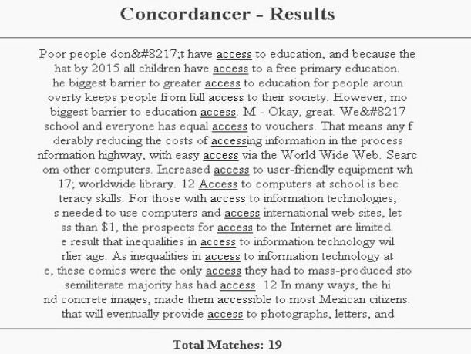
Example of concordance.

The task: Production

The course books had been analysed and the lexical items chosen, so what was the next stage? What did we want to do with the information? The first step was to form lists of vocabulary for each unit. These lists weren’t simply ‘here are fifty words you can find in unit 1’, rather, they gave frequency of occurrence and reference to the page where the item could be found. While Folse rebuts the notion that word lists are an entirely unproductive way of presenting vocabulary, and that they ‘help in tackling the tremendous task of learning enough vocabulary to be able to communicate in their new language’ (Folse (2004: 37)), this didn’t do enough to fulfill the school’s intent to adequately support the students’ studies in terms of vocabulary. Furthermore, while the project thus far had satisfied the CEF guidelines by having decided ‘which lexical elements... the learner will need/be equipped/be required to recognise and/or use’ and ‘how they [the lexical items] are selected and ordered’ (Council for Cultural Co-operation, Education Committee, Modern Languages Division (2001: 112)), the needs of the students and the CEF’s suggestions on how learners should be expected/required to develop their vocabulary necessitated that the project develop further. Indeed, the CEF guidelines were to a great extent instrumental in deciding the next steps of the project. Of the many suggested methods of development of learner’s linguistic competence, several, given the context, stood out as being either practical or practicable. The aforementioned word lists were one of the suggestions, but others were considered important; inclusion in context (course book texts); presenting with visuals; learner training; and explanation and training in the application of lexical structure (word formation, collocation, etc). All of these factors played a part in the next stage of the project, the vocabulary companions.

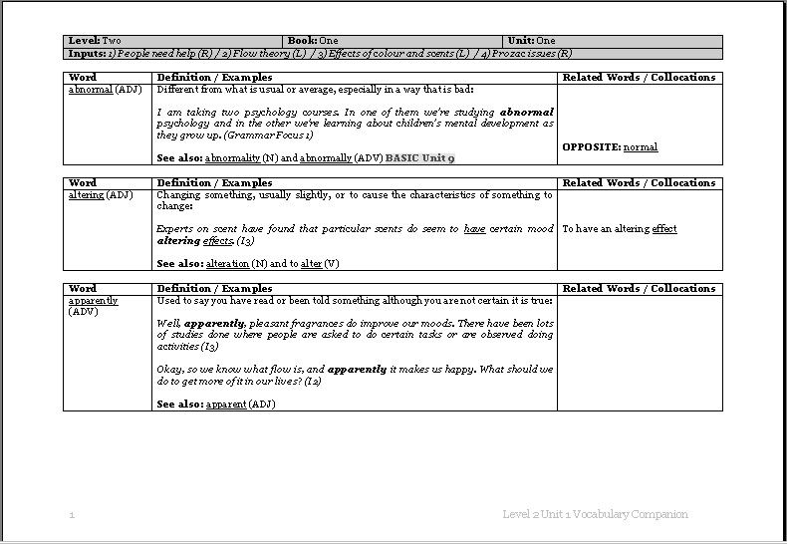
Example page of a vocabulary companion.

Ostensibly a mini-dictionary, the vocabulary companions were developed as a series (one for each unit of each book) of reference documents to which the students could refer to gain further information about lexis. With regard to developing linguistic competence, it was decided that the companions would be developed with a number of considerations in mind. Firstly, the companions had to reflect the word lists, i.e. contain the same vocabulary items, therefore becoming a natural progression from the word list, where words are presented in isolation, to a document that would foster a deeper level of understanding. With this in mind the companions were written to contain many pieces of relevant information; definition(s); example(s) in context; word formation; collocations; antonyms/synonyms; and reference to examples in other units where the item appeared. By following this formula, it became clear that the companion would be a valuable reference document and go some way to fulfilling the suggestions laid out in the CEF. However, this was not all. The companion had to be something that could act as a springboard to greater development of vocabulary acquisition. In other words, materials were required to exploit the companion and further justify its place within the overall syllabus. It would not have been enough to merely refer students to the companion for ‘further information on vocabulary item X.’ What was needed was a series of materials that could take learners on the journey from first encountering the lexis to the point where they would be able to use it in written/spoken production. What form would such documents take? How would such activities be described in a syllabus?

It was decided to develop activities that would take learners through the process of knowing a word; the form (spoken, written and word parts); the meaning (the concept of the word, its referents and its associations); and usage (grammatical functions, collocations and constraints such as register and frequency) (Nation (2001: 27)). Furthermore, the activities would form structured levels of vocabulary development, taking into consideration factors such as; recognizing the word in spoken/written form; recognizing affixes and relating these to meaning; knowing the meaning in a particular context, and that meanings are influenced by context; knowing that certain words are related; recognizing when the word has been used correctly; and recognizing common collocations and connotation (Nation (2001: 26-28)). In order to do this (and to set descriptors for the project in the syllabus), activities were developed under three headings; Stage One – First Encounters; Stage Two – Getting to know the word; and Stage Three – Using the word. A fourth level, labeled Stage Zero, was also included in order to further satisfy the CEF guidelines, which focused on learner training materials. The CEF guidelines also suggest syllabus writers may wish to consider, ‘what size... range... control of vocabulary the learner will need/be equipped/be required to control' (Council for Cultural Co-operation, Education Committee, Modern Languages Division (2001: 150)). The question of size had been dealt with in the formation of the lists (the top 2000 and the AWL/UWL) and the range via the thematic contents of the course books (themes that students would encounter when embarking on their continuing academic studies). Therefore, the four-stage approach would serve to define how the level of control was to be defined. So, how?

Stage One activities were developed so as to treat the lexical items as if it were the students’ first encounter with the vocabulary. Clearly, with the existence of the companion documents, the students were receiving a greater level of support than a learner meeting the word in an everyday uncontrolled situation, especially as the examples used in the companions were lifted directly from the reading texts and listening scripts. Therefore, the Stage One activities stressed such strategies as guessing meaning from supported/controlled context.
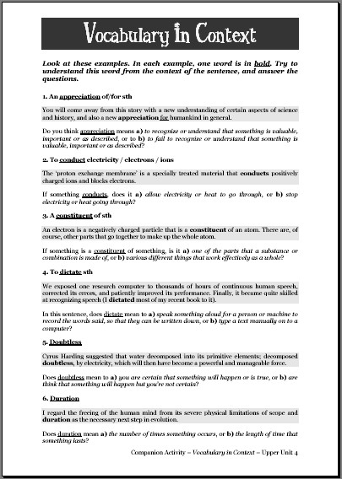
In the above example, the student is required to choose which of the given definitions is true. Several similar activities were developed, with the aim of giving the learner an entry point to the journey of understanding a word.

Zwier (2002: 14) notes the importance of EAP materials that target productive vocabulary and address collocations, usage restrictions and other elements relating to using a word. The Stage Two activities addressed such issues, and necessitated that students develop a deeper level of understanding of the lexical item. The examples below show two of the activities used to develop greater level of cognition.

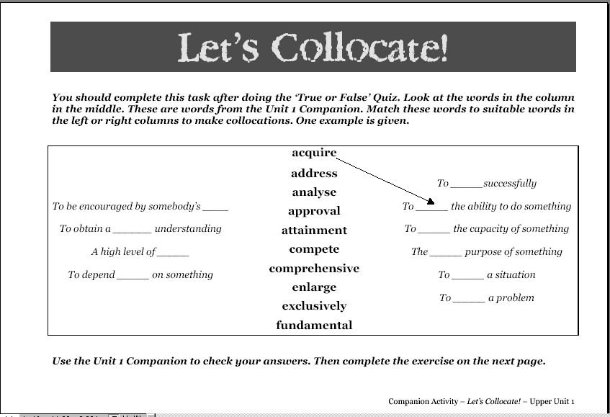

In these examples, the students are required to do such tasks as recognise the grammar associated with the lexical item (does it require the use of the infinitive or gerund?) and develop their knowledge of some of the strong collocations and lexical chunks associated with each item. The students, in other words, are moving past viewing the words in isolation.

Stage Three activities created needs for the students to use the vocabulary productively. Such activities required the learners to complete such tasks as making sentences from prompts (for the example below, with the lexical item excuse, the learner is required to write a sentence using the collocation to make an excuse) and writing quizzes for other learners and classes.

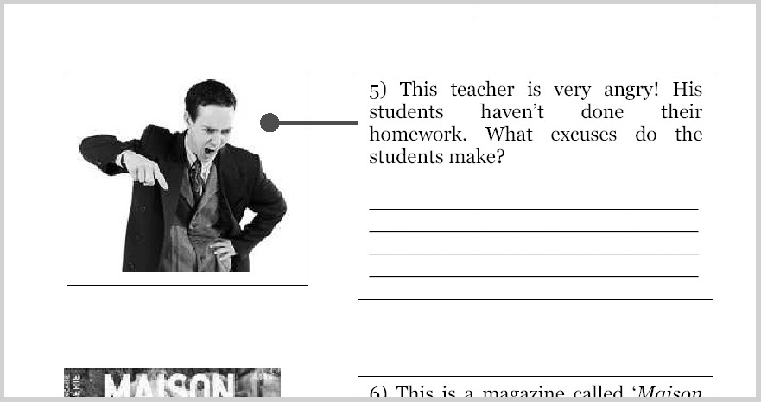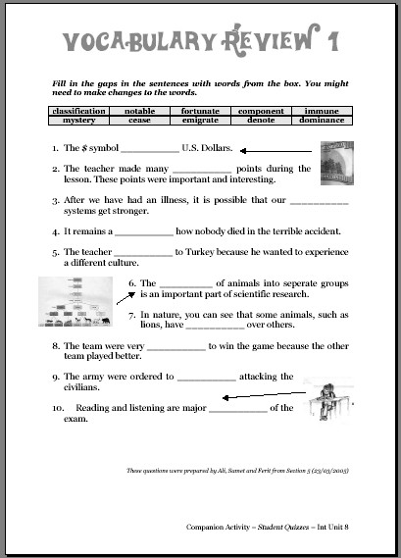

One of the fears of using a relatively small corpus, in the region of 250,000 words, was that the amount of data available to develop linguistic competence would be insufficient. For instance, would the course books provide good examples of the grammar of the lexis or indicate typical strong collocations? One way in which this issue was addressed was in the development of Stage Zero activities, for learner training. A typical activity was to assign particular lexical items to groups of students and have them research that word on the Internet. A good website for doing this is the BBC’s news website (http://news.bbc.co.uk/).

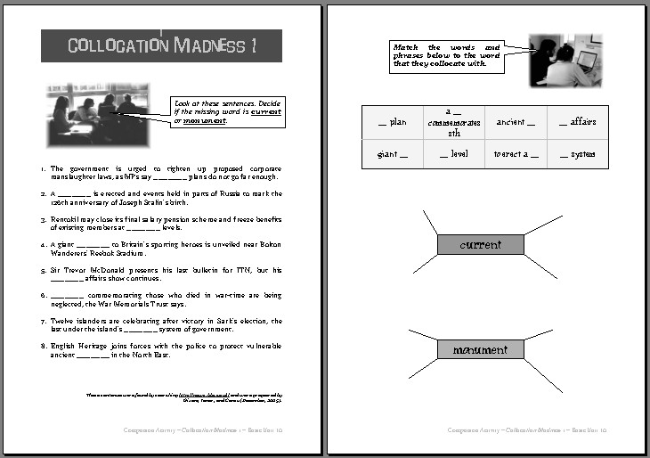

By searching using the lexical item as the keyword, a list of headlines were shown, from which collocations could be observed. As the above example shows, these collocations were then used by students to prepare materials to share with their friends. Other, more typical learner training resources were devised, such as materials discussing methods of recording vocabulary. With these four stages in place, it was time to ask whether or not these materials were adequate, were they doing the job?

Feedback

Two forms of feedback were received. Firstly, semi-formal teacher feedback, in the form of feedback sheets, was obtained. Three main issues became evident: i) The number of unit-specific items was considered too high, and it was feared that students were spending too much time studying non-essential vocabulary, ii) there was insufficient recycling of essential vocabulary, and iii) further assessment practice was required for students to measure their progress. The consequences of these comments were as follows; the unit specific vocabulary was revised and the number of items reduced; vocabulary items are now recycled to a greater extent across levels (words presented at lower levels are generally presented again at the higher levels); and quizzes were prepared for each unit.

Students were also asked for their feedback on the resources produced. Feedback was taken in the form of group interviews and samples were taken from students at all levels of proficiency. As with the teachers’ feedback, several interesting points arose as a result. One of these was that the materials had to be ‘motivating’. The goals and objectives of the materials were intended to be as relevant to the students as possible, but Hutchinson & Waters (1987: 48) make a relevant point: 'The medicine of relevance may…need to be sweetened with the sugar of enjoyment, fun, creativity and a sense of achievement.' This was a point picked up on by many of the interviewees. The example below shows one way in which this issue was addressed.

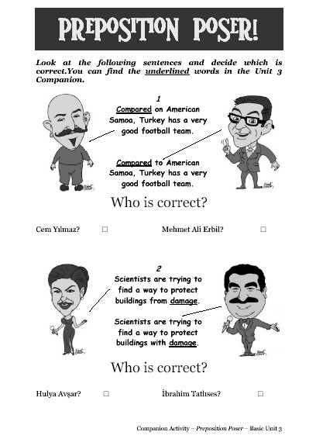

Using pictures of famous Turkish celebrities meant that the vocabulary being presented became more meaningful, and the task more enjoyable. Learners noted that task containing visual stimuli helped them to retain the vocabulary and made doing the exercises more pleasurable. Other examples that students picked up on were the learner training activity mentioned previously, and other activities that promoted autonomy and creativity. Another important issue raised was that of spending time on vocabulary work in class. Students strongly indicated that they felt time spent working with the materials in class to be more valuable than having to work through the materials themselves. Interviewees particularly noted the motivational benefits of being assessed on vocabulary, and that this increased their inclination to study independently.

Conclusion – Future Aims

Has enough been done? To qualify the response to this question, Laufer’s suggestion that: ‘The level at which good L1 readers can be expected to transfer their reading strategies is 3,000 word families’ (Laufer in Coady & Huckin (1997:24)) can be considered. Are the 2,500+ being presented adequate preparation for university study? Feedback from students suggested that they felt that the materials available to them were greatly aiding them in terms of vocabulary acquisition, although it is perhaps too early to note the degree of success. With the project still, to some extent, being in its developmental stages, no students have gone on to their freshman studies having worked with the companions and materials. Consequently, the long-term plan for the project is to assess the degree to which those students currently in the preparatory program cope with the demands of academic study in subsequent years. Laufer’s notion raises another point for consideration. The project work was based primarily on the analysis of reading, and the corpus was ostensibly a text-based one. The future direction of the project may necessitate the need to evaluate the corpus from a spoken-word perspective. Additionally, the inclusion of student-generated activities offers the opportunity for the development of a student-corpus, the analysis of which would provide valuable data for the improvement of materials based on such issues as typical learner errors.

References

- Brown, J.D., (1995), The Elements of Language Curriculum. NEWBURY HOUSE
- Coxhead, A. (2000) A New Academic Word List. TESOL Quarterly, 34, (2), 213 - 238.
- Council for Cultural Co-operation, Education Committee, Modern Languages Division, Strasbourg (2001) Common European Framework of Reference for Languages: Learning, Teaching, Assessment. CUP
- Graves, K. (Ed.), (1996), Teachers as Course Developers. CUP
- Hutchinson, T. and Waters, A., (1987) English For Specific Purposes: A Learning Centered Approach. CUP
- Nation, I.S.P. (2001) Learning Vocabulary in another Language. CUP
- Nunan, D., (1999) Second Language Teaching and Learning. HEINLE & HEINLE
- Xue Guoyi and Nation, I.S.P. (1984) A university word list. LANGUAGE LEARNING AND COMMUNICATION (3), 215-229.
- Zwier, L.J. (2002) Building Academic Vocabulary. UNIVERSITY OF MICHIGAN PRESS

Other sources used

- Wikipedia Internet Encyclopedia, Common European Framework of Reference for Languages, http://en.wikipedia.org/wiki/Common_European_Framework_of_Reference_for_Languages, (accessed 23/03/2006)
- Massey University School of Languages, AWL resources, http://language.massey.ac.nz/staff/awl/index.shtml, accessed (24/03/2006)

More information on the Beyond the Boundaries course book series can be obtained from the Sabancı University School of Languages website, http://www.sabanciuniv.edu/do/eng/.

