Processing and Properties of New Generation Radiation Shielding Nano Composites

Cengiz Kaya^{1,2,*}, Suna Avcıoglu^{3,4}, Merve Buldu^{1,2} , Figen Kaya⁴, Cem Bülent Üstündağ⁵, Erol Kam⁶, Yusuf Z. Menceloğlu ^{1,2,7}

¹Materials Science and Nano Engineering, Faculty of Engineering and Natural Sciences, Sabancı University, Turkey
²Nanotechnology Research and Application Centre (SUNUM), Sabancı University, Turkey
Email*: cengizkaya@sabanciuniv.edu, web site: http://www.sabanciuniv.edu
³Department of Materials Science and Engineering, Faculty of Engineering, Ondokuz Mayıs University, Turkey
⁴Department of Metallurgical and Materials Engineering, Faculty of Chemistry and Metallurgy, Yildiz Technical University, Turkey
⁵Department of Bioengineering, Faculty of Chemistry and Metallurgy, Yildiz Technical University, Turkey
⁶Department of Physics, Faculty of Arts and Science, Yildiz Technical University, Turkey
⁷ Sabancı University Integrated Manufacturing Technologies Research and Application Center (SU IMC)

Abstract

Electromagnetic radiation from equipments in medical diagnostic centers or nuclear reactors causes ionization including gamma rays and x-rays that are well known to be very harmful to human health. Therefore, flexible, light-weighed and environmentally friendly shielding materials that can replace toxic and very heavy Pb based materials are required.

In the present work, synthesized and surface modified micro/nano B₄C particles are distributed within polymeric matrices in order to obtain flexible shielding materials. The effect of surface functionalization and concentration of boron carbide on the distribution characteristics of boron carbide and the final properties of the composites are examined.
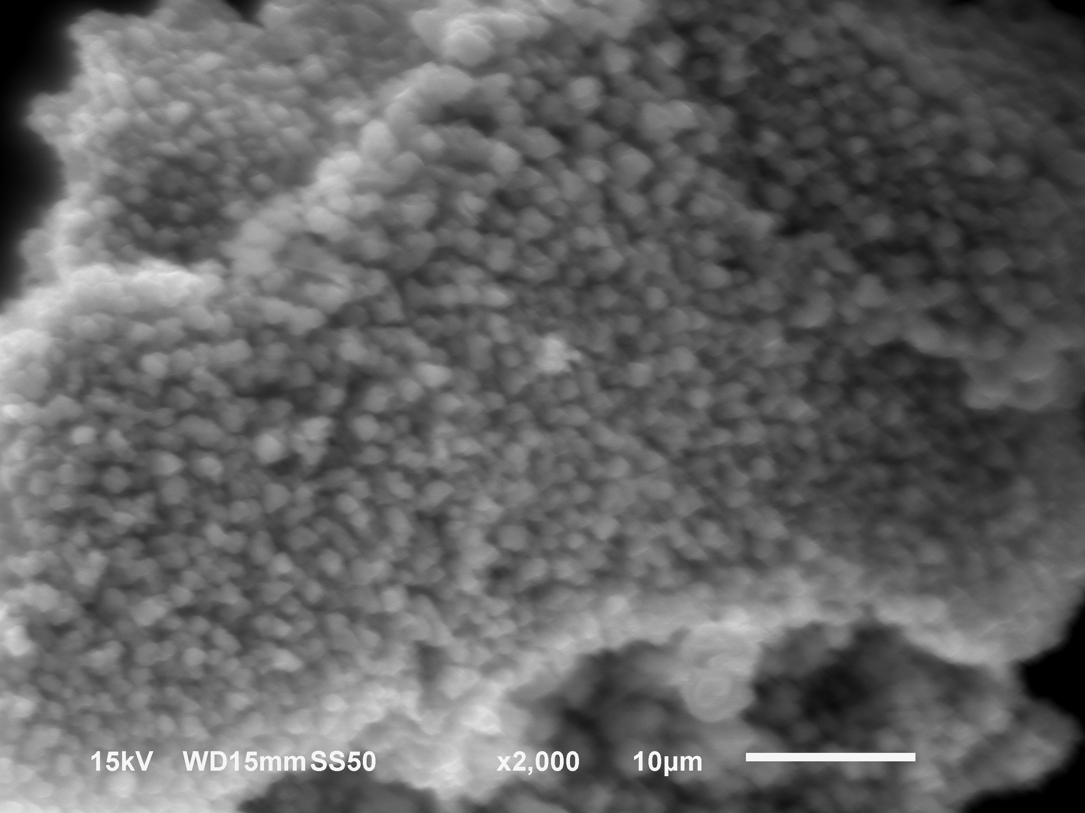
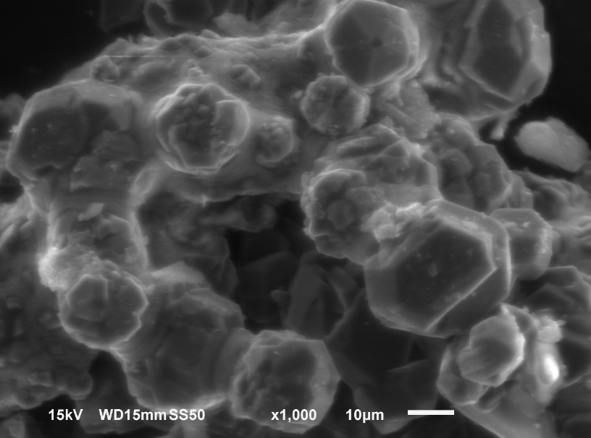

- b)

Fig. 1. The SEM images of the B₄C particles showing the effect of starting composition in the sol gel process on the particle morphology for the samples sintered at 1400 ºC for 5h; (a) tartaric acid, citric acid.

The Figure 1 (a) shows the SEM image of the sol-gel derived boron carbide powders after sintering at 1400 ºC for 5h indicating that B₄C particles with spherical morphology are obtained using citric acid in the starting composition while mostly hexagonal/polyhedral shaped morphology is achievable using tartaric acid, as shown in Fig. 1b.

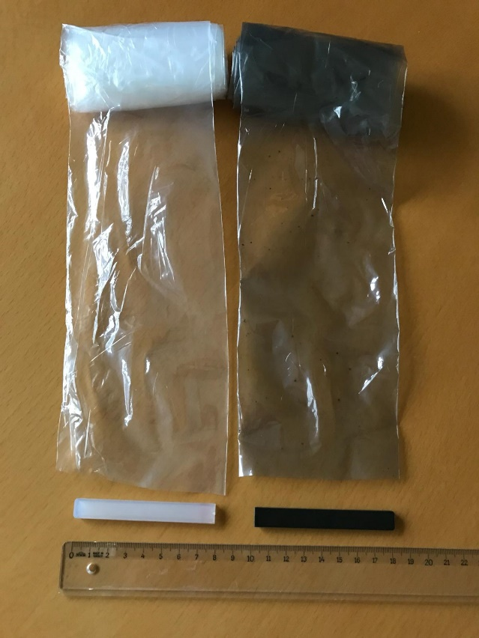
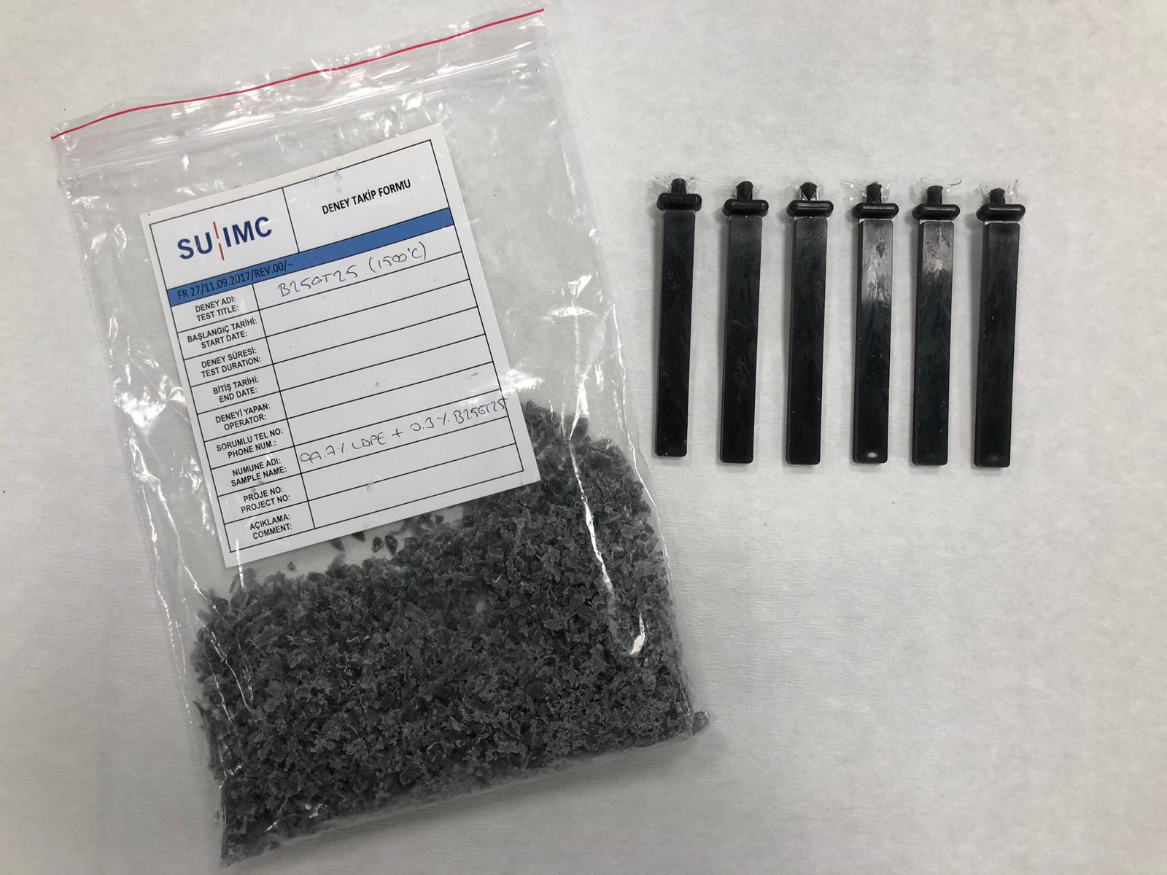
- b)

Fig. 2. The optical micrographs of the surface modified boron carbide particle containing polyethylene composites plates (a) and flexible sheets (b) for measuring shielding properties.

As shown in Figure 2 that the obtained boron carbide particles are successfully distributed within the polymeric matrices to obtain composites in the form of plate or very thin sheets (a and b, respectively) for the purpose of measuring shielding properties. It is also found that as the amount of boron carbide is increased within the composites, better shielding properties are recorded.

Acknowledgements

The authors are grateful for the financial support from the The Scientific and Technological Research Councel of Turkey (TUBITAK) under the contract numbers of 216M140 and 216M145.

Presentation Method: Invited Oral (30 min presentation)
Suggested Session: Nanostructures and Nanomaterials
Desired presentation date: 5 July 2019

