Hysteresis in Cavitating Flows within Transparent Microchips
¹Ece Ozdemir; ¹Berk Ozer; ¹Gokberk Deprem; ¹Ahmad Reza Motezakker, ²Luis Guillermo Villanueva, ^{1,3}Morteza Ghorbani; ^{1,3}Ali Koşar;
¹Faculty of Engineering and Natural Science, Sabanci University, Orhanli, Tuzla, Istanbul 34956, Turkey
²Department of Mechanical Engineering, École Polytechnique Fedérale de Lausanne, Lausanne CH-1015, Switzerland
³Sabanci University Nanotechnology Research and Application Center, 34956 Tuzla, Istanbul, Turkey

Abstract
Cavitation phenomenon has attracted much attention in engineering applications so the industry has provided considerable funding during recent years. Despite the simplicity and rather low price of small devices generating cavitation bubbles, the physics behind the creation and collapse of these bubble is still not well understood particularly in micro/nano scale. The assessment of size effects is vital for the design and development of new generation microfluidic devices involving phase change. Additionally, as the length scale decreases, surface nuclei dominate and dictate cavitation events. The modifications in the microchip geometry and enhancement in the micro device performance in applications involving cavitation will lead to increased cavitation bubbles number, reduced noise, improved bubbles collapse and increased energy sustainability. This study aims to investigate the creation of cavitation bubbles and classify the cavitating flow patterns in a novel roughened microchannel configuration. Cavitating flows are characterized in a transparent microchannel configuration in order to achieve a comprehensive understanding of cavitation inception and collapse in micro scale, which are crucial in the development of new-generation energy harvesting systems. In this device, a restrictive element and a big channel downstream of the restrictive element are mainly considered. The microchip consists of two main wafers, namely silicon and glass, which are anodically bonded together to withstand high pressures. The flow rate and discharge are evaluated at the outlet of the channels to characterize the chocking flow conditions in micro scale. The flow characteristics are determined to recognize differences in flow physics between smooth and roughened micro channels. Moreover, cavitation number, which is a major parameter for flow patterns, is considered in order to have valuable insights to the inception, development and collapse of the cavitation phenomenon in micro scale. Furthermore, the surface characteristics are also considered in detail in the microchip, and the effect of surface roughness on cavitating flows is investigated.
Keywords: cavitation; microchannel; roughness; pressure
Introduction
Cavitation is today’s one of the hottest topic in different fields of technology. It could make it possible to acquire new power generation possibilities in order to achieve clean technology and energy savings which can be well generated in micro scale. Many studies have revealed that the collapse process of a cavitation bubble is extremely violent, and within the bubble, the gas can become extremely hot in micro/nano scale [1,2]. Hydrodynamic cavitation occurs in micro channels as a result of flow constriction. Micro channels with different structures and geometries may induce various types of cavitating flow patterns. Furthermore, thermophysical properties along with the surface topology can affect the creation of cavitation bubbles and their collapse. Upstream pressure values play a major role in the cavitation and the pressure inside the micro-channel [3,4]. The numerical studies in the micro scale hydrodynamic cavitation has shown that the intensity of the bubble generation is raised once the size of the channel is reduced [5,6]. Meanwhile, the static pressure as a significant parameter in the creation and collapse of the cavitation bubbles decreases to very low values along the micro channel particularly near the end of the channel. To study the cavitation in micro scale, there is a need to shift conventional configurations to microchip format, which is called “cavitation on chip”. Therefore, it is required to develop techniques to increase the efficiency of the devices capable of generation cavitation bubbles [7]. In this study, hydrodynamic cavitation is studied in two different micro channels with different side wall roughnesses. The experiments have carried out at different upstream pressures to investigate cavitating flows. It is aimed to show the effect of different types of roughness on the generation of cavitation bubbles and utilize them in microfluidic systems for energy harvesting.
Methods and Materials
A high-pressure pure nitrogen tank (Linde Gas, Gebze, Kocaeli) supplies the required upstream pressure for the system. This tank is connected to a 1 Gallon fluid reservoir (Swagelok, Erbusco BS, Italy), which is filled with de-ionized (DI) water and serves as the working fluid. The reservoir is connected to the system with adaptor fittings. Four pressure sensors (Omega, USA) are mounted at the end of the tubing system and on the device package to measure the pressures. Two fine control valves (Swagelok) are integrated to the system to control the flow at the desired locations. A micro T-type filter (Swagelok) with a nominal pore size of 15 µm is used to filter any particles larger than 15 µm. A power LED source serves for illumination to have high quality records.

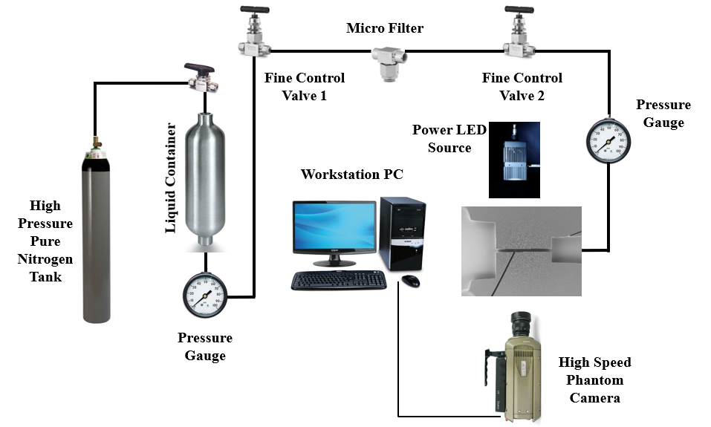
Figure 1: A schematic of the proposed system for generating cavitation bubbles and micro/mini cavitating jets.

The flow setup is shown in Figure 1. The inlet pressure varies between 5-60 bars. Although microchips have different roughness, they all have the same inlet structure which fits to the same package. Micro-chips are sandwiched to the package with screw mechanisms to allow for withstanding inlet pressures of the liquid up to around 60 bars. Liquid flow is controlled by valves at different locations. There are three pressure gauges on the setup to check for the pressure values, which are inlet, outlet, and the channel pressures. Images are recorded with a CMOS camera, which has 1280x800 resolution with very short time delay. The flow rate is measured and the effect of the discharge on the creation of the cavitation bubbles is obtained. The flow rate is measured by recording the level of the accumulated water level with respect to time.
Fabrication Process of Microchips
The device houses silicon and glass wafers, which are durable to high pressures. The channels, edges, surface roughness, inlet and outlets are formed on the silicon wafer, while the glass wafer is used as the top layer of the device for visualization purposes. The fabrication process includes three main steps, namely lithography, etching and bonding. Lithography process on the double side polished silicon wafer involves the exposure of suitable photoresist, coating of channels and development. The microfluidic device ensures a continuous access to the fluidic system including inlet, outlet and pressure ports. The fabricated devices integrated to the fabricated packages are durable to high pressures (up to 2000 Psi). The process flow for the fabrication of the microfluidic device is shown in Figure 2. Table 1 shows the dimensions of the microchannels.

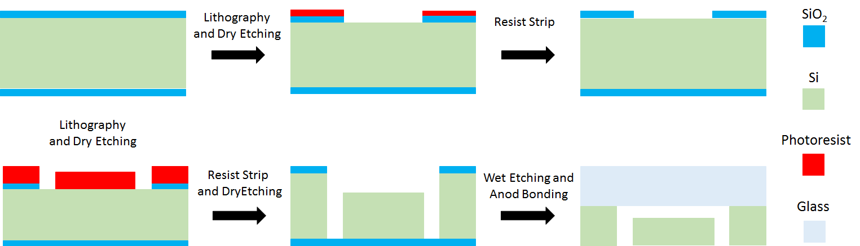
Figure 2: A schematic of the fabrication process of the microchips

Micro channel | Width of nozzle | Roughness | Length of nozzle
Smooth | 200 µm | 0 | 2 mm
Side Wall Roughened | 200 µm | 2 µm | 2 mm

Table 1: Device dimensions and roughness
Results
The intensity of cavitation along the channel is characterized by cavitation number:
$σ=\frac{P_{ref}-P_{V}}{\frac{1}{2}ρ_{l}V_{ref}^{2}}$ (1)
where $ρ_{l}$ is liquid density, $P_{ref}$ is reference pressure which is the upstream pressure in this work, $P_{V}$ is vapor saturation pressure (working fluid in this work is water and vapor saturation pressure for water is 3540 Pa), and $V_{ref}$ is reference velocity at the outlet of the microchannel, calculated with the use of mass flow rate, which varies according to the flow conditions.
Table 2 displays cavitation numbers extracted from the raw data for two different chips.

 | Side Wall |  |  | Smooth
P-inlet (Psi) | P-1 (Psi) | t(s) | $$σ$$ | P-1 (Psi) | t(s) | $$σ$$
145 | 98 | 39 | 8.95E-01 | 110 | 51 | 1.20E+00
310 | 235 | 23 | 7.48E-01 | 245 | 32.5 | 1.09E+00
450 | 387 | 17 | 6.74E-01 | 380 | 25 | 9.97E-01
595 | 512 | 13 | 5.21E-01 | 525 | 20.6 | 9.36E-01
775 | 667 | 12 | 5.79E-01 | 660 | 18.6 | 9.59E-01
920 | 814 | 12 | 7.07E-01 | 790 | 17.8 | 1.05E+00
1075 | 944 | 11 | 6.89E-01 | 930 | 17 | 1.13E+00
Table 2: Cavitation number and upstream pressure for different channels
P-1 is the pressure at the entrance of the microchannel and t is the time for discharging of 20 ml liquid.
Figure 3 is extracted from Table 2 for smooth and side wall roughened micro channels. It is shown that the cavitation number has a lower value for side wall roughened micro channel in comparison to the smooth one for the identical pressures.

Figure 3: Cavitation numbers of two chips with respect to the input pressure
From this figure, it can be deduced that although the effect of changing the input pressure is observed as creating a “valley” that cavitation number intensifies as we move away from a minimum point, which here appears to be as around 600 Psi, the act of switching from the smooth channel to the channel with side wall roughness produces much successful results in increasing the cavitation number.
The outcomes of this study show that the cavitation phenomenon occurs as a result of the thermophysical and geometrical changes in the fabricated micro- chips. The roughness of side wall sharply facilitates the inception and development of cavitating flows. The interaction between the bubbles collapse and the solid exposed to the flow is expected to increase the thermal gradients on the surface, which could be exploited in power generation. The results in Figures 4 and 5 show that the cavitating pattern is the same for smooth microchannel at the inlet pressure of 920 Psi and the channel with side wall roughness at the inlet pressure of 450 Psi. However, the pattern for the side wall roughness channel at inlet pressure of 1070 Psi corresponds to fully developed super-cavitation, which is not seen in the similar smooth channel at this pressure. Thus, roughness leads to early transitions between flow patterns.

P-in (psi) | 450 | 595 | 775 | 920 | 1075
Smooth | 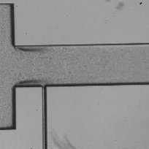 | 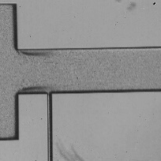 | 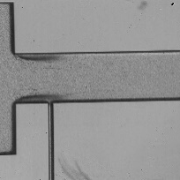 | 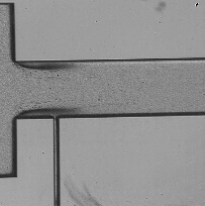 | 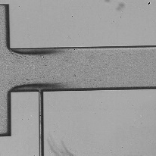
2-1 Side Wall | 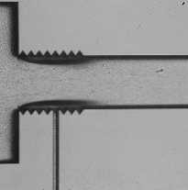 | 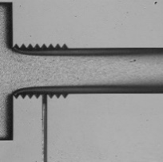 | 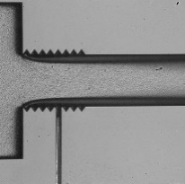 | 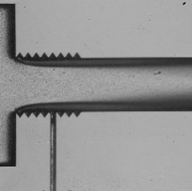 | 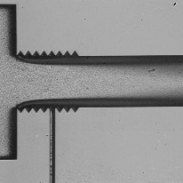
Figure 4: Cavitating flow occurrence inside the micro channel for different upstream pressures in smooth channel and channel with wall roughness

P-in (psi) | 450 | 595 | 775 | 920 | 1075
Smooth
2-1 Side Wall |  |  |  | 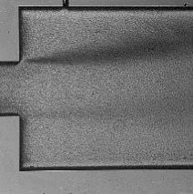
Figure 5: Cavitating flow occurrence inside the extended channel for different upstream pressures in smooth channel and channel with wall roughness
Conclusion
In this study, the cavitation phenomenon inside micro chips was studied. It is shown that the cavitation bubbles are generated inside short micro channels with any geometrical and topological properties at specific pressure drop inside the restrictive element. It is revealed that the side wall roughness has a significant effect on the generation of cavitation bubbles in a shorter period. Therefore, it is possible to reach developed cavitating flows in a side wall roughened micro channel at a lower upstream pressure. Meanwhile, it was proven that the fabricated microchips are durable to very high pressures.
References
[1] Qin, Z., & Alehossein, H. (2016). Heat transfer during cavitation bubble collapse. Applied Thermal Engineering, 105, 1067-1075. doi:10.1016/j.applthermaleng.2016.01.049.
[2] Yang, S., Jaw, S., & Yeh, K. (2009). Single cavitation bubble generation and observation of the bubble collapse flow induced by a pressure wave. Experiments in Fluids, 47(2), 343-355. doi:10.1007/s00348-009-0670-1.
[3] Ghorbani, M., Sadaghiani, A. K., Mohammadi, A., Alcan, G., Unel, M., Koşar, A., & Gozuacik, D. (2018). Characterization and pressure drop correlation for sprays under the effect of micro scale cavitation. Experimental Thermal & Fluid Science, 9189-102. doi:10.1016/j.expthermflusci.2017.10.005.
[4] Ghorbani, M., Alcan, G., Unel, M., Sabanovic, A., Uvet, H., Gozuacik, D., and Kosar, A., ‘Visualization of microscale cavitating flow regimes via particle shadow sizing imaging and vision based estimation of the cone angle’, Experimental Thermal and Fluid Sciences, Volume 78, 322-333, 2016.
[5] Ghorbani, M., Khalili Sadaghiani, A., Yildiz, M., and Kosar, A., ‘Experimental and Numerical Investigations on the Spray Collapse under the Effect of Cavitation Phenomenon in a Microchannel’, Journal of Mechanical Sciences and Technology, Volume 31, Issue 1, 235-247, 2017.
[6] Ghorbani, M., Yildiz, M., Gozuacik, D., and Kosar, A., ‘Cavitating Nozzle Flow in Micro and Mini Channels under the Effect of Turbulence, Journal of Mechanical Sciences and Technology, Volume 30, Issue 6, 2565-2581, 2016.
[7] Gothsch, T., Richter, C., Beinert, S., Schilcher, C., Schilde, C., Büttgenbach, S., & Kwade, A. (2016). Effect of cavitation on dispersion and emulsification process in high-pressure microsystems (HPMS). Chemical Engineering Science, 144239-248. doi:10.1016/j.ces.2016.01.034.

