Effect of microwave pre-radiation on graphene preparation
Zahra Gohari, Yuda Yurum
Faculty of Engineering and Natural Sciences, Sabanci University, Orhanli, Tuzla, Istanbul 34956, Turkey
yyurum@sabanciuniv.edu
Introduction
Widespread and remarkable properties of graphene sheets have attracted many researchers recently to produce graphene base materials. Various production methods have been demonstrated, such as chemical exfoliation of graphite known as the most economical way to achieve monolayer graphene.
Experimental
Aim of this study is to investigate microwave radiation effect on subsequent oxidation and reduction processes of graphite flake and graphite oxide (GO) respectively. In this work, sulfuric acid was used to oxidize graphite flakes; 1) in presence of NaNO3 and KMnO4 (Hummer method) and 2) with nitric acid and KClO3 (Staudenmaier method). Moreover, GO samples were reduced by thermal process to compare with microwave reduction.
At each step, samples were characterized by X-Ray diffraction (XRD), field emission scanning electron microscopy (FESEM) and Raman spectroscopy techniques.
Results and Discussion
Results showed that applying microwave radiation for short time period before oxidation process (Fig1.) increased density of defects and decreased crystalline domain size of graphite flakes. Microwave pre-radiated graphite flakes exhibited higher degree of disorder after oxidation process in comparison to graphite without pre-radiation.
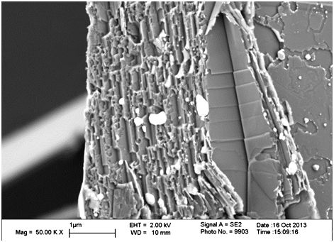
Figure 1. effect of microwave radiation on graphite flakes.
Conclusions
These findings clearly indicate that graphene can be prepared by microwave assisted chemical method with less consuming energy in cost effective process.
References
- Huang,C.C; Pu,M.W; Chung,A.W; Huang,J.C; Sung,Y; and Ger,M.D; Separation and Purification Technology, 2011,44, pp. 210–215.
- Zhu,Y; Murali, SH;D. Stoller,M; Velamakanni,A; D. Piner,R; and S. Ruoff,R; Carbon, 2010, In press.
- Poh,H.L; San,F; Ambrosi,A; Zhao,G; Sofer,Z; and Pumera,M; Nanoscale, 2012, 4, 3515.

