UTILIZATION OF FUNCTIONALIZED GRAPHENE AND ITS NANOCOMPOSITES AS A CATALYST SUPPORT IN FUEL CELLS

Burcu Saner Okan¹, Selmiye Alkan Gursel², Yuda Yürüm²

¹Sabanci University Nanotechnology Research and Application Center, SUNUM, 34956 Tuzla Istanbul, Turkey

²Sabancı University, Faculty of Engineering and Natural Sciences, 34956 Tuzla Istanbul, Turkey

bsanerokan@sabanciuniv.edu

Introduction
Catalyst support materials have great influence on the cost, performance and the durability of fuel cells. A well qualified support material should have exceptional gas permeability, high electrical conductivity, smooth surface, good mechanical strength, proper wettability, stable chemical and heat properties, as well as low cost [1]. In fuel cells, generally carbon black is utilized as the supporting material for Pt due to its high surface area and low cost. Nevertheless, carbon black has some performance and stability issues under fuel cell operation. Therefore, graphene has larger specific surface area, better electrical conductivity, and more flexible structure, which make graphene appropriate for fuel cell applications [2, 3]. In addition, graphene nanosheets (GNS) dispersed in the polymer matrix provide a stronger catalyst-support interaction [4] and produce smaller catalyst particles which are more resistant to degradation [5]. The production of novel catalyst support materials could open up new ways in order to enhance the catalytic activity by reduced catalyst loading. At this point, nanocomposites composed of conducting polymers like polypyrrole (PPy) reinforced with GNS are being considered as catalyst support for fuel cell applications. In the present work, the effect of chemical properties of graphite oxide (GO) sheets, GNS and their nanocomposites on catalyst size, dispersion and surface chemistry was investigated in detail to fabricate novel catalyst support materials.

Experimental
Exfoliation of graphene nanosheets. GNS were exfoliated from graphite flakes applying by an improved, safer and mild chemical route including oxidation, ultrasonic vibration and chemical reduction in large quantity [2, 3].
Production of graphene-based nanocomposites. Then, polypyrrole (PPy) was coated on both GO sheets and GNS by in situ polymerization of Py by using FeCl₃ as the oxidant in the mixture of ethanol andnwater for 24 h.
Deposition of Pt nanoparticles on PPy based nanocomposites. Pt deposition on the surface of nanocomposites was conducted by applying three different deposition methods including direct and sonication techniques. The effect of sonication process on the dispersion of Pt particles on the surfaces was investigated by comparing the methods.
Fabrication of thin-film electrodes. Powder samples, GO sheets, GNS, their composites, were mixed by 10% Nafion® solution using as a binder in distilled water under ultrasonic treatment at room temperature for 30 min. Then, the mixture was poured onto Nafion® 117 membrane to prepare homogeneously dispersed and thin film and to remove the film easily from Nafion® surface. The performance of the fabricated fuel cells has been tested in a single fuel cell.

Results and Discussion
GNS were produced in large quantities by chemical exfoliation of graphite [3, 4] and separate sheets were shown in Figure 1 a. Py intercalated into GNS during in situ polymerization and polymerized on GNS layer-by-layer. Uniformly layer coating of PPy/GNS composites and spherical morphology of PPy nanoparticles on sheets were seen clearly in Figure 1 b.
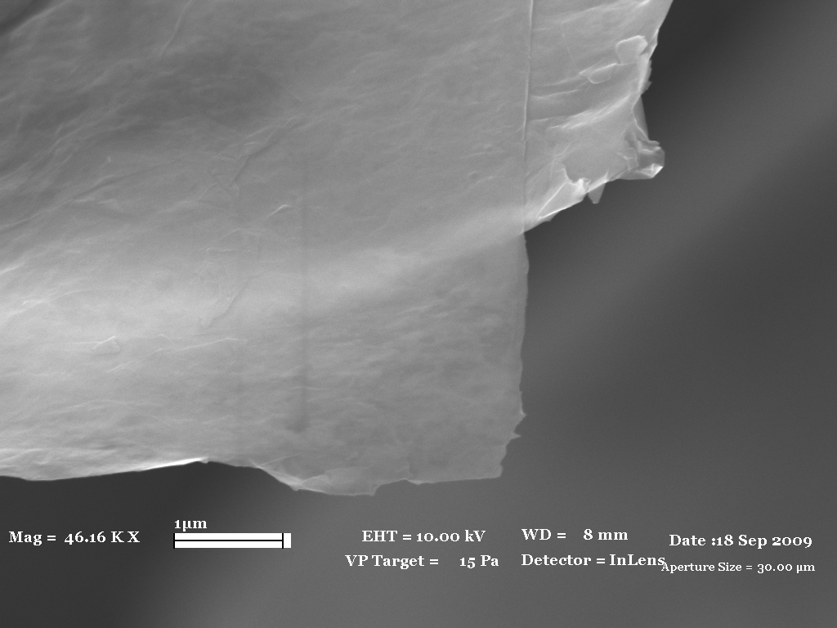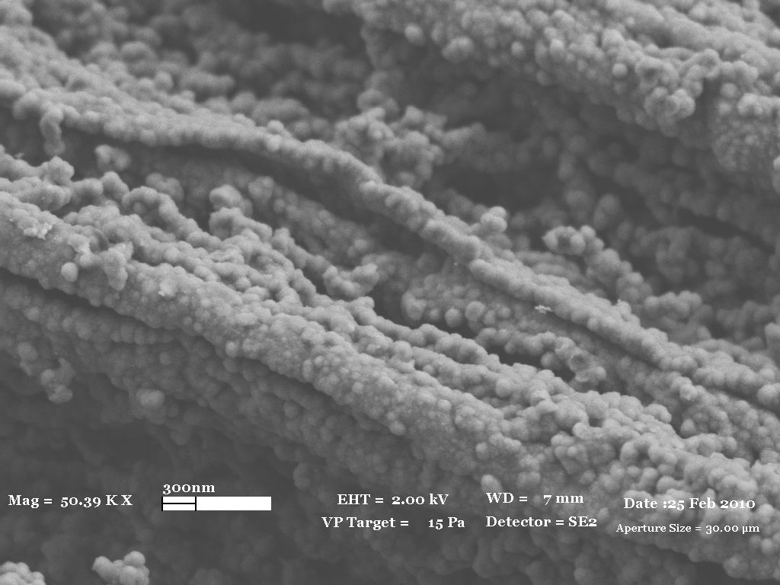
(a)
(b)
Figure 1. Scanning electron microscope (SEM) images of (a) GNS and (b) PPy/GNS nanocomposites

In the PPy/GNS composites, GNS are electron acceptors while PPy serves as an electron donor. Therefore, coating by PPy on GNS induced electronic conduction, and the adhesion of Pt on the membrane surface was significantly enhanced. In Figure 2 a, Pt particles decorated closely each other on the surface. Size distribution of Pt particles changed between 20-40 nm. SEM image of this sample at higher magnification exhibited that Pt catalysts started to grow on each other during deposition process and their size were approximately 5 nm, Figure b.
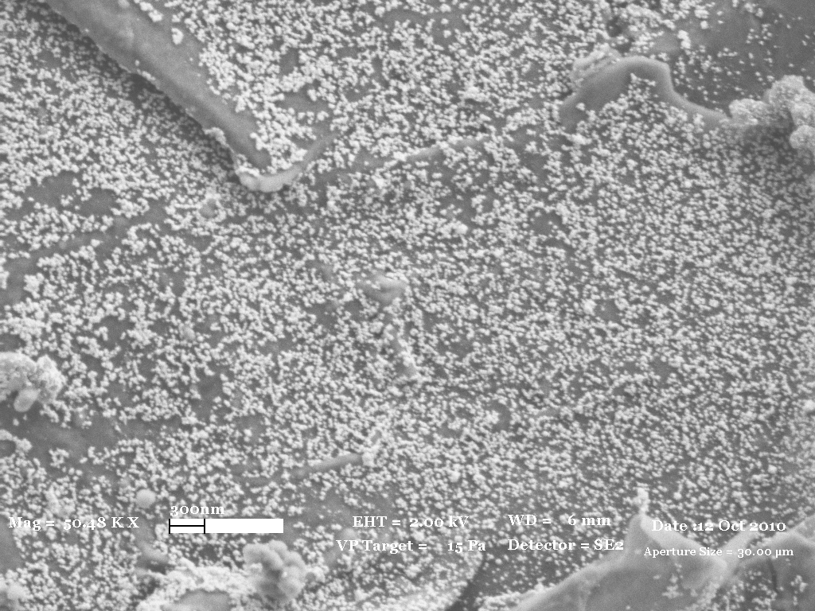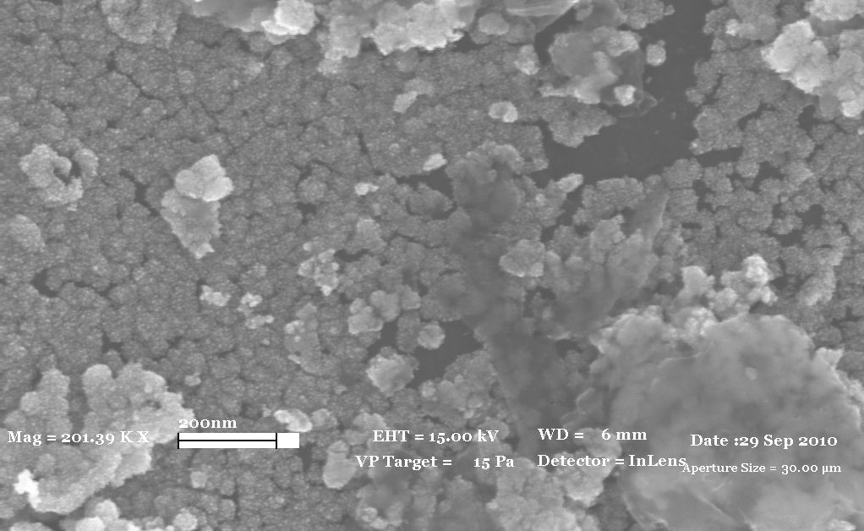
(a)
(b)
Figure 2. SEM images (a) and (b) of Pt dispersed Py:GNS=1:1 nanocomposites at different magnifications

Conclusions

The impact of physical and chemical aspects of GO sheets, GNS and their nanocomposites had a great influence on catalyst size, dispersion and surface chemistry. By comparing the results of three different impregnation techniques, the shortest and most effective impregnation technique was achieved by Pt deposition under ultrasonic vibration about 2 h. SEM characterization demonstrated that the deposition of Pt on PPy/GNS nanocomposite by sonication technique was more applicable than on bare GNS. Higher catalyst dispersion on the surface of Py:GO=1:1 composite without the aggregation of Pt catalysts was achieved since few GO layers provided higher specific surface area for a stronger metal-support interaction and thus prevent the aggregation of catalyst particles.

References
(1) Shao, Y.; Liu, J.; Wang, Y.; Lin, Y. J. Mater. Chem., 2009, 19 (46), 59.
- Saner, B.; Okyay, F.; Yurum, Y. Fuel, 2010, 89 (8), 1903.
- Saner, B.; Dinc, F.; Yurum, Y. Fuel, 2011, 90, 2609.
- Saner, B.; Alkan Gürsel, S.; Yurum, Y. Fuller. Nanotub. Car. N. 2013, 21, 233.
- Kou, R.; Shao, Y.; Wang, D.; Engelhard, M. H.; Kwak, J. H.; Wang, J.; Viswanathan, V. V.; Wang, C.; Lin, Y.; Wang, Y.; Aksay, I. A.; Liu, J.; Electrochem. Commun., 2009, 11(5), 954.

