The Tower and the Quest: A Storytelling Space for Avatars
Elif Ayiter
Sabancı University,
Istanbul Turkey
ayiter@sabanciuniv.edu

Heidi Dahslveen
Oslo and Akershus University College of Applied Sciences, Oslo, Norway.
Heidi.Dahlsveen@hioa.no

Abstract
In this text we discuss a project that was co-authored by a storyteller and a visual artist in the metaverse of Second Life in 2009. The aim of the project was to create a storytelling space that would be used by its visitors to create their own unique narratives as well as their own original performances, all of which would take their trajectories by being immersed in a virtual architecture/landscape, through avatar costumes and a substantial library of dramatic poses and animations that were put at their disposal by the authors at the location of the event. The project wove together several concepts: These are Roy Ascott’s tenets of ‘distributed authorship’ and ‘participatory poesis,’ which were brought together with a term that was coined by Axel Bruns to describe novel collaborative electronic forms of creative output in which the roles of the ‘user’ and the ‘producer’ have become merged, manifesting as a novel type of online behavior which the author defines as ‘produsage.’ These primary concepts were substantiated by research that combined the fields of performance art, storytelling, memory arts and the usage of mnemonic devices, including the Renaissance notion of the ‘memory theater’ with Cyberpsychology, particularly in relation to avatar studies.

Keywords

Avatar, Metaverse, Produsage, Second Life, Storytelling, Performance.
Introduction
‘The Tower and the Quest’ was created as the result of an offer made to us in the autumn of 2009 to participate as invited artist in an annual art festival organized by Linden Labs in Second Life©. This event receives its name, as well as its overall concept, from the famed Burning Man festival that is annually held in the Black Rock Desert in Nevada, USA. Thus, during the few weeks of ‘Burning Life’ – as the festival is called in Second Life, a large number of simulators are turned into an initially empty arid desert which gets built upon by the residents of the world. Our goal was to create a space following Roy Ascott’s concepts of ‘distributed authorship’ and ‘participatory poesis.’ (Ascott 2003: 191-208) Consequently, our primary concept was that our project would unfold not solely through our own creative work but rather through its extension into the work of others, who we hoped would become creatively active in the space that we had built for them. We wanted to create a storytelling space where the participants were given impulses to create their own stories. These impulses were provided from three areas: landscape, characters and static as well as moving poses.

We were both aware that a noteworthy occupation of our fellow metaverse residents was the creation and enactment of stories that they constructed whilst visiting spaces that were created by others. Very often these visits were undertaken dressed in clothes or artifacts purchased from elsewhere, which were used as elaborate props with which the location visited would be further augmented. The outcomes were virtual photographs, videos and blog posts in which creative work inspired by the visit would be shared. As content creators this chain of artistic activity interested both of us greatly in that it appeared to be very much in synch with online collective and distributed creative endeavors that have been termed as ‘Produsage’ by Axel Bruns, who has brought together the words ‘producer’ and ‘user’ in order to describe such creative behaviors and environments. Consequently, ‘Produsage’ defines virtual output that is community-based, while a further characteristic of ‘Produsage’ is also that within such communities the roles of creator and user remain fluid and interchangeable at all times. (Bruns 2008: 1)

Based upon this observation we saw a unique opportunity to pool our resources as storyteller and visual designer to create a custom built storytelling space that we would present to the usage of our visitors, in the expectation that they would use our combined output as points of trajectories for their own creative work; particularly when it came to creating their own stories that would evolve out of what we put at their disposal. The overall idea for the project came out of the Tarot of Marseilles. However; it was not the cultural, historical or spiritual part of the card deck that primarily held our interest. Instead it was the clearly depicted and archetypal characters that were represented on the cards which easily could activate stories that gave the impetus for the project.

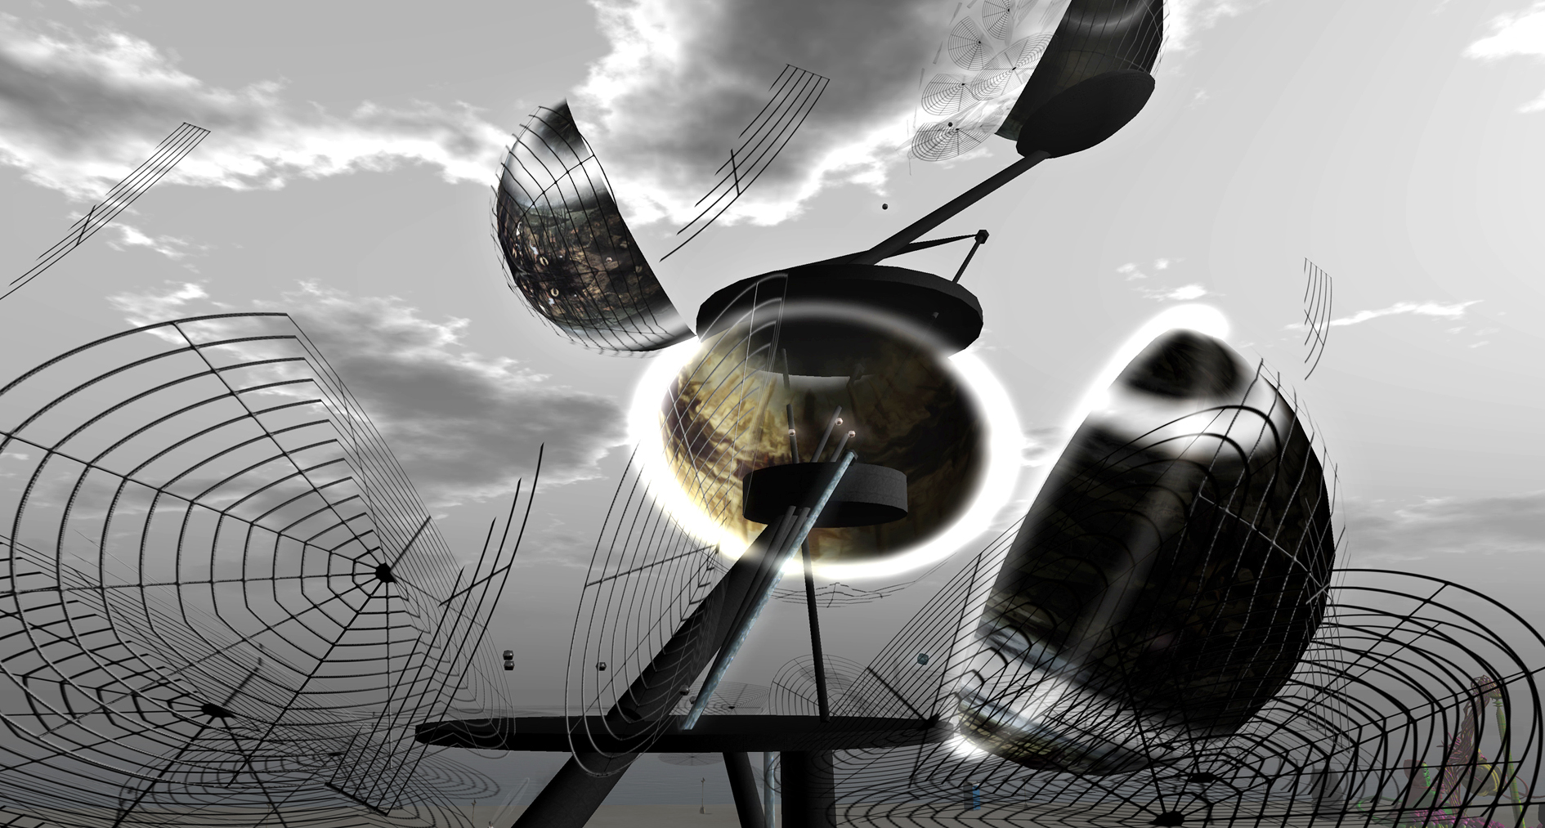

Fig 1. Detail of the architecture, showing the spherical stages for story-telling. Second Life, 2009.

What we gave them to play with was an architecture into which we embedded 5 stages, five full avatar costumes complete with skins, and a vast assortment of custom designed dramatic poses and animations through which they could put their avatars into various performative roles. We also supplied them with a very short introductory text which would help set them onto the task of constructing narratives and stories that would help save the tower from falling over:

“Not that long ago a group of avatars traveled into the desert in search of an answer to the question ‘where do we come from and where do we go?’ The outcome of their quest is the creation of a site for story-telling, performance, exploration, learning, play, relaxation and entertainment for all avatars.

They dug in the ground to find water and constructed a tower made of the materials they brought with them. Within this construct specific places were created for the 5 cards of the Major Arcana of the Tarot. ‘The Fool,’ ‘The Hermit,’ ‘Temperance,’ ‘The Chariot’ and ‘The Moon’ – all telling their own individual stories as well as stories together.

Sadly the questing friends had no luck: Almost as soon as they had finished it the tower started bending over. The water they found never managed to reach the top of their construct and it is only a question of how long the tower will now survive. Will you help them by adding your stories to theirs, since stories and tales are in fact the ‘water’ that the tower needs?”

The Project: The Tower and the Quest

The frame of the project was built on the idea of traditional stories, particularly on how they treat the landscape and characters in their narratives. Traditional storytelling is closely related to memory art. A good clarification to this term can be found in Cicero's description of how such memory art arose in the Roman legend of Simonides who had to leave a dinner party and thus avoided being killed when the building collapsed and killed the remaining guests. To remember who was present Simonides reconstructed a mental map based upon the locations of the guests around the table by means of which he could tell who was present.

Location (loci) has thus been central to the history of memory art: “A mnemonic technique based on spatial and visual logics, the memory palace took root in Ancient Rome, as it was described by both Cicero and Quintillian. Deploying the method of loci, the user essentially maps memories into an imaginary architectural space.” (Uricchio 2012: p.45) Just as it is essential for rhetoric, location is also essential for the traditional storytelling since the landscape of the story is being used by the storyteller to remember the story. (Dahlsveen 2008) When it comes to virtual spaces however, the great dilemma of creating a landscape in these is that what has been created and used for storytelling purposes is more than likely is likely to disappear within a very short period of time. One does not have a chance to walk through it 5 – 6 years later as one could do in a real city to seek out cultural, historical and personal memories: “The spaces we traverse are loaded with signification, silent witnesses to the unfolding of the past and active triggers for the associations and experiences of countless other subjects in our present.” (Uricchio 2012 p.47)
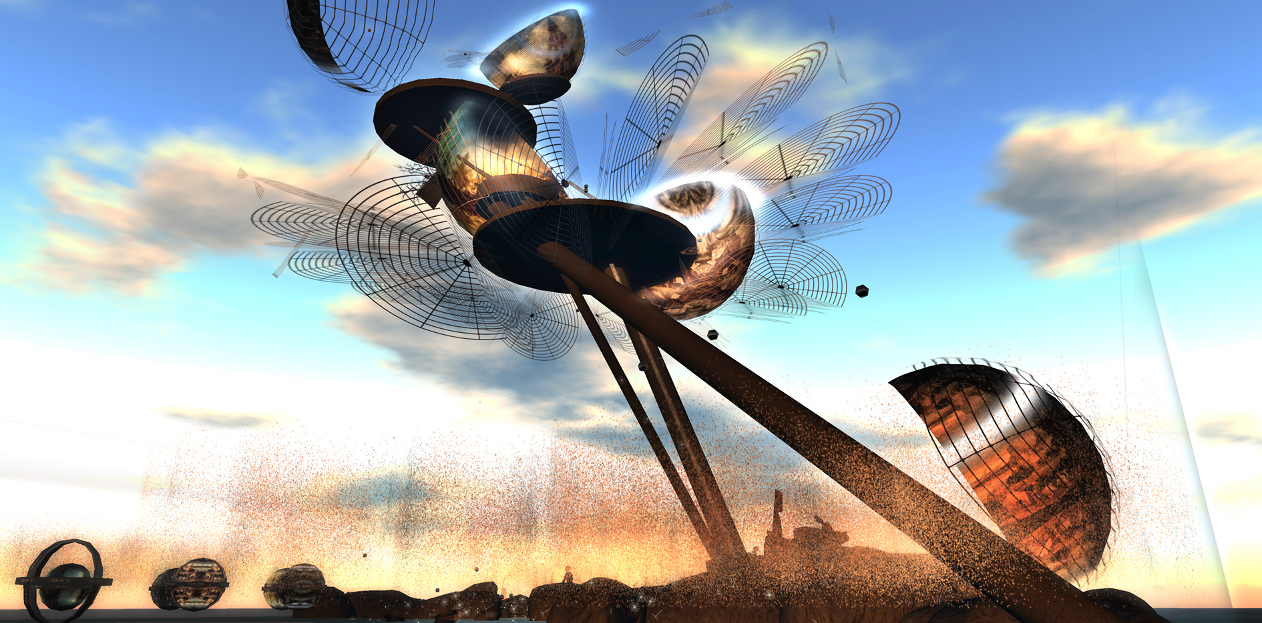

Fig 2. Overview of the architecture. Second Life, 2009.

From this it may be inferred that such an awareness of the transience and the ephemerality of the landscape in which they reside may cause the inhabitants of a virtual world to be active in the collection of memories. In other words, the participants of a story-telling endeavor are not merely passive recipients but instead actively “wandering subjects” (Uricchio 2012: p. 49) who are the actors in their own stories.

Thus emerged the concept of using the avatars of the participants themselves and the virtual landscape that surrounded them in such a way that they could act upon the mind as mnemotechnic devices that would aid story-telling in a virtual world. Noted should be that this approach has its historic precedents, particularly in the work of the mysterious Camillo (1480 – 1544) who created what has been called a ‘Memory Theatre’ (Matussek 2012: 8-15). This was a construction of wood shaped like an amphitheater, with the difference that the spectator himself was placed on the stage where he could look up at seven rows of seats. There were pictures depicting objects that were placed in order to ‘help’ the spectator's memory. Interestingly enough however, the motives of the pictures was not obvious and clear:

Their meaning is not immediately obvious but rather ambiguous and enigmatic. The images therefore demand mental activity from the spectator. This mental activity is not just logical, like solving a riddle. It takes as its starting point the strange effect produced by the almost surreal allegorical constellation of human and animal faces.” (Matussek 2012: p. 11)

When it came to our project the tower that we constructed was not shaped like a ‘memory theater’ although its function was the same: We aimed that the memories of the participants would be shaken into activity while they read between the images, the characters that were brought into being through the avatar costumes which they could wear, and the text which would compel them to fill in the void by using their own imagination, consequently creating their own stories based upon the initial impetus that we provided.
The tower was a precariously contradictory construct that combined fragility with an industrial sturdiness that defied physical gravity and was intended to give the impression of toppling over at any moment. Although the overall theme of the project was developed around the symbology of the Tarot of Marseilles, we made a point of staying away from historic architectural references that might have seemed more in synch with such a theme in the construct.
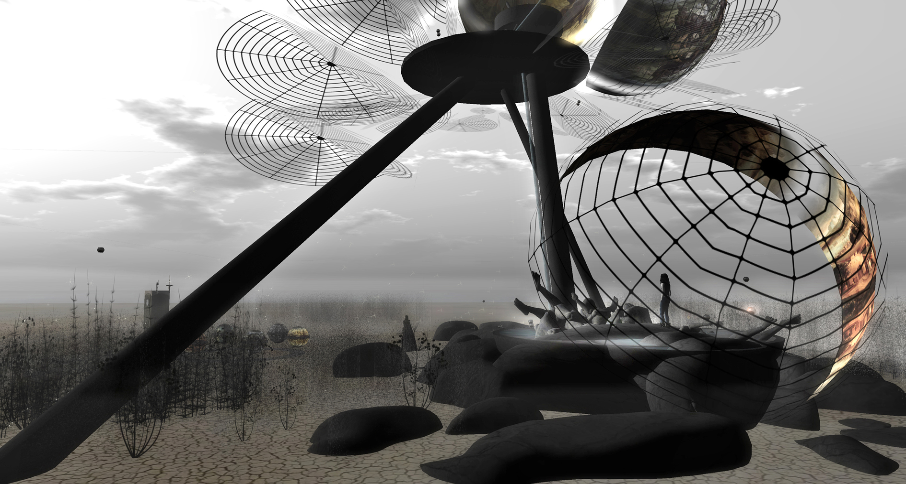

Fig 3. Detail of the architecture, showing the ground level pool. Second Life, 2009.

The landscape around the tower was made out of dried tumbleweedlike bushes which were placed around large dark rocks and boulders that also provided group seating areas for story-telling sessions that the visitors of the installation were expected to embark upon. Two elements also became important components of the desert ambience: The first of these were suffocatingly dense dust and pollen clouds placed at the ground level, and the second was a sound scape which consisted of natural sounds such as hyena laughter, rattle snakes, bats, crows, insects, and wind.

Although the structure of the tower did not derive from an adaptation of historically architectural styles that might have been considered to be more in keeping with the imagery of the Tarot cards, the 5 spherical stages that represented the symbology of the cards did in fact contain historical references: We textured their insides with visuals that were derived from late Renaissance and Baroque landscape paintings which were chosen to fit the characteristics of the individual cards.

Thus, as one moved closer into the construct the visual language altered. This play between the elements of two disparate visual styles was part of a deliberate design strategy which we hoped would create diversity in the stories and other types of creative output that would be generated by others through the project. In other words, what we attempted was creating a guiding hand which would allow for much wider interpretations through the universality/diversity of the symbols provided by the five ‘Tarot avatars’ and the precarious industrial architecture that they were placed in.

At the ground level there was a pool, which held the water which (according to our introductory text) we had found in the desert and which we had been unable to pump into the upper levels of the tower. This area was also the seat of one of the spherical stages. The pool itself had a rather dissettling component in that it held sculpted body parts that were partially submerged in the water. Through these we wished to refer to some of the associations related to the ‘The Fool’ of the Tarot deck who was the provisional actor of this first stage – the spirit in search of experience who is oblivious to the perils involved, thus representing mystical cleverness bereft of reason, seemingly unconcerned that he is standing on a precipice, apparently about to step off.

Similarly, the other four stages were created with the attributes of the Tarot cards which they represented, particularly through the dramatic poses and animations that we placed in each of these stages. These were surrounded by concave semi-spheres onto which we mapped the historically inspired imagery. However, we made a concerted effort to remain non-specific both with the visual material that we used as well as with the animations that we provided since our goal was not to have visitors generate stories that were related closely to a particular content but rather to leave them free to explore their own associations and weave them into their own tales which the content that we gave them was hoped to provoke.

The 5 avatars were based on the images of the 5 related major arcana cards of the Tarot of Marseilles, and carried the objects and wore the clothing that is associated with these cards. However, in some cases considerable liberty was taken during the adaptations of the original appearances: Thus, while the two dogs on the card of ‘The Moon’ stand on the ground; in our interpretation they reside on the avatar itself. In the case of the female version they cover her breasts; whereas in the male version one of them faces the front by being placed on the chest, while the second one is placed on the back, and thus looks backward.

The decision to use Tarot cards as the primary source of inspiration of the storytelling space stemmed from the universality of the symbols that the cards held and that, as described above, we tried to carry into the design of the avatar costumes as well. We did not expect the cards to be used for divination purposes, but instead we emphasized their narrative aspects, the metaphors which could be derived from them through a further note card which we placed at the entrance of the installation. We also urged our visitors to combine the Tarot costumes, to place the dressed up avatars in spheres that were not related to the conglomerated attire, to engage in group play and storytelling sessions during which avatars representing different tarot cards would converge and interact to bring forth ever novel tales.

2.1 The Avatar as Performer/Storyteller

Vladimir Propp showed through his studies of Russian folktales how characters in a folktale are described through their functions in the story. Or to put it more precisely, in folktales a function is “understood as an act of a character, defined from the point of view of its significance for the course of action” (Propp 1968: 21) A folktale does not come with an inner psychological description of the character, but the character is manifested through their active actions. Even though the functions of a folktale can be described independent of a character, Propp says that there are nevertheless still ‘spheres of actions’ that can be linked to specific characters, whereby “one might note that many functions logically join together into certainties spheres. These spheres in toto correspond to their respective performers. They are spheres of actions.” (Propp 1968: 79)

In our project the 5 avatars got their own sets of static and moving poses that could be associated with their functions, however rendered in such a way that the visitors/participants were not being restricted by them. According to Propp such a distinction between characters and functions makes it possible to replace characters without compromising the action of a story. A hero may be an old woman or a young girl and still carry out the same actions and through these actions will be recognized as a hero. Because a character is recognized through actions, it was necessary for us to include poses that would then serve as help to find the character's function in the participants' own stories. The British storyteller Ben Haggarty underlines that there are three simultaneously active languages when you tell a story (Dahlsveen 2008: p.73): The language of action, the language of description and the language of feeling. In our project the language of action would come about through the poses, the language of description would enabled by the space and the avatar costumes, and the language of feeling would be manifested through the point of view that the participants created their individual stories from.

Although a story is often understood as a structure that moves linearly and cognitively; Alber et al. differ from this definition by emphasizing the existence of an ‘unnatural narratology,’ which is one that breaks with the mimetic, and looks at the story as it moves beyond what is perceived as possible in a linear or cognitive manner. Thus, the story “may radically deconstruct the anthropomorphic narrator, the traditional human character, and the minds associated with them, or they move beyond real-world notions of time and space, thus taking us to the most remote territories of conceptual possibilities.”(Alber et al 2010:p. 114)

While the dramaturgical process can have four angles – text, time, space and body (Gladsø et al 2005: 187), for the ‘Tower and the Quest’ of these four ‘body’ (the avatars) and ‘space’ (the architecture) were the two primary angles that were utilized. The characters drawn from Tarot cards, which we described above, formed the basis for the avatars, as well as the stages upon which they were expected to enact their stories – which in their turn formed platforms for creative output; particularly as props and backdrops for the images and videos that we expected would be generated out of the installation.

Richard Schechner notes upon several different aspects of a performance, which he draws from different performative traditions. One of Schechner’s primary considerations is the term ‘transport,’ which he tells us should always be present in any successful performance, since the performer/participant should literally ‘go into another world’ to partake in such action. A second term that Schechner applies to performative undertakings is ‘transformation’ which brings about a change in the performer’s self-representation during the performance itself and furthermore this change is expected to retain a lingering effect after the performance is over. (Schechner 1981: 83)
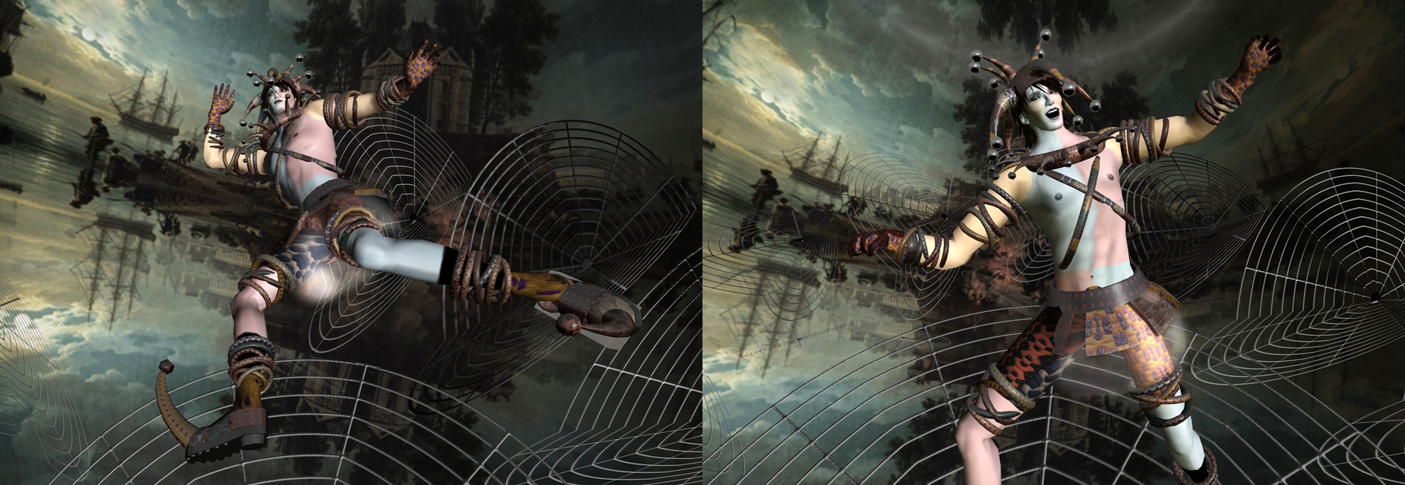

Fig 4. ‘The Fool’: Two instances of a photographic storytelling series by avatar Jurgen Maurer (avatar name). Courtesy of the artist. Second Life, 2009.

Schechner’s findings seem to find considerable resonance when considered in relationship to avatars, as Yee and Bailenson’s research on the effects of virtual embodiment, as well as Jacquelyn Ford Morie's research on the performative aspects of the avatar suggests:

Yee and Bailenson have demonstrated that the appearance of the avatar has a deep influence on the behavior and on the self-perception of its human handler – not only in the virtual world itself – even more importantly this change is transferred into subsequent behavior and perceptions in Real Life as well. In effect, the findings of their study, ‘The Proteus Effect,’ show us that avatars are psychological extensions of ourselves whose power and impact on the workings of our psyche needs to be taken into full account and deeply considered. (Yee and Bailenson 2009: 285–312)

Looking at avatars and virtual worlds from a performative vantage point Jacquelyn Ford Morie suggests that there has been a recent paradigm shift in human experience that has been brought on by these phenomena. Morie points at the research of performance artists that contributes to the exploration of virtual environments as a key to our future understanding of ourselves in physical and digital domains, which takes on “an experiential locus that is outside the perceptual self.” This, according to Morie, signifies “a shift to a dualistic existence that occurs in two simultaneous bodies” through which the lived body has now “bifurcated and become two.” (Morie 2007: 123-138)

When the findings of these authors are juxtaposed with Schechner’s tenets one may conclude that Morie’s observations on avatars accounts for Schechner’s concept of ‘transport,’ albeit in a dualistic sense of the word, given that while we are transported into another world through the bodies of our avatars, we yet remain in our physical bodies simultaneously. Yee and Bailenson’s ‘Proteus Effect,’ on the other hand, seems to provide grounds for validating Schechner’s notion of ‘transformation,’ since their findings show that altered self-perception which extends beyond the moment of ‘performance’ is achieved quite spontaneously through the body of the avatar.

Our own observations verify that avatars are in fact powerful creative agents that are capable of evoking ‘transportation’ and ‘transformation.’ As such they can also be seen as potent performers and story tellers, bringing to the fore unexpected talents in their human handlers in these creative domains. During the month that our project was visited by thousands of avatars as part of the Second Life festival, we were gratified to see the countless stories and creative performances that came into being inside our architecture, through our avatar costumes, and the dramatic poses and animations that we had made available as story creation aids.

As the project unfolded we saw that in many of the cases the output held strong performative elements – often also accompanied by stories or other types of narrative. Very much in the spirit of ‘Produsage’ (the mode of collaborative electronic production in which the roles of ‘user’ and ‘producer’ are merged, and that was discussed at the onset of this text), our visitors surprised us by establishing creative chains that went beyond our wildest expectations. This became particularly evident after the showing of the work at Burning Life 2009 was brought to a close; realized through the avatar costumes and animations that continued to be widely used outside of the original installation that we had created. They were brought together with the artifacts of many other designers and artists resulting in innovative hybrid creations that provided further stories and play activity across the grid of Second Life; transpiring at many islands that featured the architecture and landscaping of other content creators.

Thus, our initial output was transformed, manipulated and used in ways and contexts in which it can easily be said that it ceased to be ours alone and ended up belonging to its owners as much as it did to us. The output, in terms of the narratives and stories that it engendered was photographed and filmed and written up by these individuals and we have tried to keep tabs on this flow as much as it was possible to do so; although even today, three years after the project we are still surprised to come across images, videos and texts that take their trajectory from our tower and its avatars.

Conclusion

‘The Tower and the Quest’ was open to visitors for one month at its original location. After the conclusion of the festival the architecture was moved to a Second Life island where it was placed directly upon the virtual sea. Although the installation had been devised for a desert environment we were surprised to see that the tower, and especially its ground level pool, fit in very well with the seascape around it.

Returning to the term ‘Produsage’ we find that Axel Bruns goes explicitly into the correlation between content creation in Second Life and ‘Produsage,’ and notes upon the “massively parallelized and decentralized creativity”; (Bruns 2008: 299) which, for him, is one of the primary characteristics of the metaverse where the productive act takes place in a networked, participatory environment which breaks down the traditional boundaries between producers and consumers and instead enables all participants to be users as well as producers of information, artifacts and knowledge – frequently in the hybrid role of ‘produser’ where usage is necessarily also productive. This definition may also be described as a creative chain, and following from this we may claim to have instigated one such chain of participatory creativity by providing the initial content, in other words by becoming its first link through the output of ‘The Tower and the Quest.’ Our chain has not remained as a solitary strand however, since it has been linked and interwoven to countless other such chains through the creative usage of our material which our visitors have ingeniously combined with the output of many other designers and artists in the metaverse.

Although nowhere near the huge numbers that participated in the project during its sojourn at the Burning life 2009 festival, the tower did continue to receive visitors at its new location until it had to be taken down a year ago, due to space considerations.
We, its two creators, continue to collaborate in projects that bring together visuality and narrative, and that also unfold within the concept of ‘Produsage,’ of which ‘The Tower and the Quest’ has turned out to be only the first.
References
Alber, j., Iversen, S., Nielsen, H. S., & Richardson, B., (2010). unnatural Narratives, unnatural Narratology: beyond Mimetic Models. Narrative, 113 - 136.

Ascott, R., Shanken, E. (ed)., (2003). Telematic Embrace: Visionary Theories of Art, Technology, and Consciousness, University of California Press, Berkeley, CA., pp: 191 – 208.

Bruns, A.: Blogs, (2008). Wikipedia, and Beyond (Digital Formations), Peter Lang, New York, pp: 1, 299.

Dahlsveen, H. (2008). Innfoeringsbok i Muntlig fortellerkunst (Translated: Introductory book to oral story-telling). Oslo: Universitetsforlaget

Gladsø, S., Gjervan, E. K., Hovik, L., & Skagen, A., (2005). Dramaturgi; forestillinger om teater (Translated: Dramaturgy: performances of/notes on theater). Oslo: Universitetsforlaget. p: 187.

Matussek, P. (2012). Memory Theatre in the Digital Age. Performance Reseach: A Journal of the Performing Arts, 17:3, 8-15.

Morie, J., (2007). Performing in (virtual) spaces: Embodiment and Being in virtual environments. International Journal of Performance Arts and Digital Media, 3(2&3), Intellect, pp.123-138.

Propp, V. I. (1968). Morphology of the folk tale (Vol. 9). Austin: University of Texas Press. pp: 21, 79.

Schechner, R., (1981). Performers and Spectators Transported and Transformed. Kenyon Review , 83.

Uricchio, W., (2012) A Palimpsest of Place and Past: Location-based digital technologies and the performance of urban space and memory, Performance Research, 17:3 pp: 45-49

Yee, N. & Bailenson, J.N., (2009). The Proteus Effect: The Effect of Transformed Self Representation on Behavior, Communication Research, 36(2), pp: 285–312.

Ayiter, E., Dahlsveen, H., (2009) Work blog for the Tower and the Quest project, http://thetowerandthequest.wordpress.com/2009/09/16/proposa/

