

Dear Morteza Ghorbani:

I am very pleased to be able to tell you that your paper titled “Numerical Study of Cavitating Flow in an Orifice and its effect on Spray Characteristics” (HYDROD-D-15-00099R1-BW15064) has now been accepted for publication in our journal, the Journal of Hydrodynamics.

Thank you for your contribution to our Journal.

Yours sincerely,

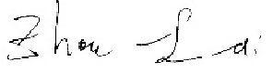

Prof. Zhou Lian-di
Executive editor in-chief of the Journal of Hydrodynamics
2017.12. 15

